K
Keene, Foxhall Parker (1867–1941)
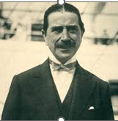
Parents: James Robert Keene (1838–1913) and Sara Joy Daingerfield (1830–1916).
Married: Mary Lawrence (1860–1942).
Children: None, though Mary had a son by her first marriage to Frank Worth White (1856–1887).
Kinship: Husband of Mary Lawrence, the great-grandaunt of the post–World War II Smith generation.
Early Life
Foxhall Parker Keene, known as “Foxie,” was born in San Francisco, where his father James R. Keene had made a fortune in the Nevada Comstock silver mines. The Keenes were symbols of Gilded Age wealth and volatility—James making and losing vast fortunes through speculation. By 1874 the family had moved east, buying a grand house on Bellevue Avenue in Newport, Rhode Island, only to lose it to fire and financial ruin.

Foxhall’s youth was already marked by risk-taking. At thirteen he won a pigeon-shooting contest in Babylon, Long Island, turning a five-dollar wager into $565—a sign of his lifelong taste for competition and gambling. He was educated privately and at Harvard, where he cultivated sportsmanship and notoriety in equal measure.

Harvard and “Bloody Monday”
At Harvard, Foxhall’s impulsive temperament got the better of him. He was suspended after organizing a riotous “Bloody Monday” party, a traditional brawl-turned-drinking-festival between freshmen and sophomores. The Boston Evening Transcript in 1891 lamented that wealthy “roistering newcomers” like Keene gave “punches” to all comers in both senses of the word.

After reinstatement, Keene joined the football team but ruptured a kidney during practice. Undeterred, he trained for Harvard’s lightweight boxing championship, befriending his classmate Jack Lawrence of Flushing, Long Island—his first link to the Lawrence family. A bout of measles kept him from the ring, and he soon left Harvard altogether.

Career and Sporting Life
Foxhall Keene’s athletic career was astonishingly diverse. He became one of America’s leading polo players, representing the United States in 1887 against England and winning Olympic gold. He also competed in the U.S. Open golf championship, raced thoroughbreds, drove in early automobile competitions for the Gordon Bennett Cup, and helped found the National Steeplechase Association.

In his memoir Full Tilt, Keene recounted countless mishaps with characteristic bravado—falls from horses, polo injuries, concussions, and near drownings. The press chronicled his accidents with grim enthusiasm: “Foxhall Keene Hurt,” “Foxhall Keene Badly Injured,” “Foxhall Keene Breaks Collarbone,” and “Foxhall Keene Injured Seriously While Hunting.” In 1913 a newspaper summarized: “He has twice been carried from the polo field for dead, blown up from an automobile, nearly drowned on a sinking yacht, dragged by runaway horses and bitten by dogs.”

Marriage and Separation
On December 11, 1892, Keene married Mary Lawrence, widow of Frank Worth White, in a quiet ceremony at her father Newbold Lawrence’s home on Twenty-Second Street in Manhattan. The couple soon sailed for England, where they lived among the hunting set in Leicestershire. Keene hunted with the Meath in Ireland and endured a near-fatal fall that left him bloodied and half-conscious, but still managed to ride eight miles home.

The marriage, however, could not endure his relentless risk-taking. Mary had to face endless headlines like these:
Keene Hurt
Foxhall Keene Hurt
Foxhall Keene Badly Hurt
Foxhall Keene Dangerously Hurt
Foxhall Keene Hurt When Thrown by Horse
Foxhall Keene Hurt Again in Polo Game
Foxhall P. Keene Hurt during a Hunt Meeting
Foxhall Keene Sustains Concussion of Brain
Foxhall Keene Injured
Foxhall Keene Injured Seriously While Hunting
Foxhall Keene Injured when Pony Stumbles
Foxhall Keene Badly Injured May Never Ride Again
Foxhall Keene Noted Horseman is Injured
Foxhall Keene Breaks Collarbone
Foxhall Keene Breaks Ankle
Foxhall Keene in Crash

By 1904 Mary had returned to her father’s house in Bayside, Long Island, and in 1909 obtained a discreet divorce on the grounds of abandonment. Friends attributed their separation to “a difference of temperament.” Mary, horse-loving and steady, had grown weary of a husband who treated every day as a new test of courage.

Character and Context
Foxhall Keene embodied the Edwardian cult of masculine daring celebrated by Theodore Roosevelt’s “strenuous life.” At a time when social critics fretted over effete men and “neurasthenia,” Keene’s fearless physicality seemed a tonic of virility. Yet his constant need for challenge also reflected a deeper anxiety—what he once called the “compulsion to prove oneself alive.” He was both a product and a victim of an age that equated manhood with peril.

Legacy
Despite his follies, Foxhall Keene was universally acknowledged as one of the greatest all-around amateurs in American sport. The New York Times called him “the most accomplished sportsman in the world.” He won an Olympic gold medal in polo, bred and raced thoroughbreds, and shaped the culture of equestrian competition on both sides of the Atlantic.
He died in 1941, leaving behind no descendants but an enduring legend—of courage verging on recklessness, elegance shadowed by obsession, and the eternal quest of men like him to be noticed, tested, and never forgotten.

Postscript in Maryland
“In 1920, American sportsman Foxhall P. Keene threw a party for 700 guests at his Monkton home on the eve of the first Foxhall Farm Trophy Team Chase. Keene created the race, held on the grounds of his home, Foxhall Farm, to encourage participation in timber racing.
On a March evening 86 years later, Taylor and Laura Pickett, the current owners of Foxhall Farm— now called Andor Farm— celebrated the 2006 race by throwing a party that sought to replicate Keene’s inaugural festivity.

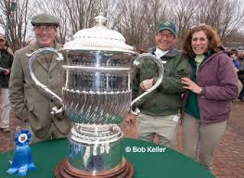
Laura Pickett called on Brian Boston, executive chef at The Milton Inn, and Carol Westerlund, owner of Larkspur Floral Design, to create a glamorous, Gatsby-esque atmosphere that would allow guests to “walk up the path and through the door and feel that they were back in the 1920s,” says Westerlund, who bedecked the Pickett home with roses, carnations and calla lilies. Female guests were given gardenia corsages at the door, while male guests donned white carnations. “It was a decadent time. We were trying to convey that,” says Boston, who baked a Lady Baltimore cake, among other fare, for the occasion. The original sterling silver Foxhall Cup was on display next to a photo album illustrating the history of the race.

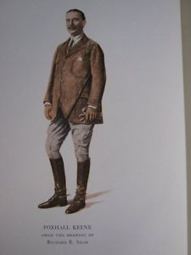
Full Tilt: The Sporting Memoirs of Foxhall Keene.
The Derrydale Press, 1938.

Keene, James Robert (1838–1913)
The Born Speculator

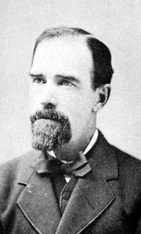

Parents: James Keene (1810–1894) and Selina Hicken (1808–1863).
Married: Sarah Joy Daingerfield (1830–1916).
Children: Jessica Harwar Keene (1867–1938) and Foxhall Parker Keene (1867–1941).
Kinship: Father-in-law of Mary Lawrence, the great-grandaunt of the post–World War II Smith generation.
Early Life and Marriage
James Robert Keene was born in England into the family of a prosperous merchant whose bankruptcy cut short his education. As a teenager, he emigrated with his family to Shasta, California, to rebuild their fortunes. He worked at any task that offered a wage—editing a newspaper, peddling milk, and even tending livestock at Fort Reading. The savings from these labors allowed him to purchase a miner’s outfit and head for the California and Nevada diggings, where he achieved modest success.

He returned to California and married Sarah Joy Daingerfield, daughter of Colonel Leroy Daingerfield of Virginia and sister of Federal Judge William Parker Daingerfield of California. The couple lived in style until James’s speculative ventures failed. Senator Reuben Fenton secured him a seat on the San Francisco Stock Exchange, allowing Keene to pay for it later. His skill as a trader soon earned him the presidency of the Exchange and a governorship of the Bank of California.

The Bonanza Fortune and Early Speculation
Keene’s first great triumph came in the Nevada Comstock Lode, where he made $6,000,000—a fortune equivalent to roughly $150,000,000 in modern value. In 1876 he left California intending to travel to Europe for his health, but Wall Street diverted his path.
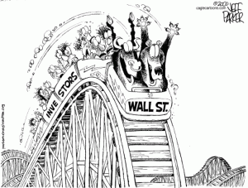

There he met his nemesis, Jay Gould, the most ruthless of the robber barons. Gould reportedly said, “Keene arrived in New York by private railroad car, and I’ll send him home to California in a boxcar.” Gould succeeded: Keene lost his fortune, and when his Newport mansion burned down, he lost nearly everything, including his prized Rosa Bonheur painting Sheep. When a visitor later saw the painting in Gould’s home, Gould allegedly sneered, “There hangs the scalp of James R. Keene.”
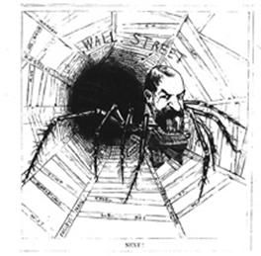
Jay Gould as seen by small investors

Rise, Fall, and Return on Wall Street
Undeterred, Keene began again. He made and lost fortunes repeatedly. In 1879–1880 he attempted to corner the wheat market but failed, losing another $3,000,000. Yet his brilliance as a market operator made him indispensable to the most powerful men in finance. He managed the affairs of Henry Havemeyer’s Sugar Trust and served J. P. Morgan’s syndicate during the battle for control of the Northern Pacific Railroad.

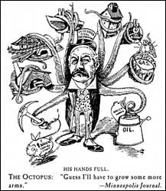
When Morgan created United States Steel in 1901, he secretly employed Keene to inflate its stock price before the offering. Keene worked through his son-in-law Talbot J. Taylor’s brokerage firm to disguise the connection. As Keene bought heavily, smaller investors rushed to follow him, believing he had insider knowledge. The stock soared from 39 to 55 before collapsing to 8¾ by 1904. Morgan and Keene profited handsomely; the public was ruined. Such “pool operations” are now strictly illegal.

Despite the ruthlessness of his methods, Keene astonished contemporaries by his sense of honor. According to his son Foxhall, when his father’s finances recovered, “his first thought was to settle up. He gave a large dinner to all his creditors. Every man found on his plate a check for the full amount owed him.”

The Psychology of the Speculator
When asked why he persisted in risky ventures, Keene replied with characteristic imagery:
“Why does a dog pursue its thousandth rabbit? He’ll chase it as though his life depended on it, and once caught, he’ll cast it aside and begin again. When you tell me why that dog wants another rabbit, I’ll tell you why I want more money.”
Keene viewed speculation as the natural expression of human creativity and daring:
“All life is a speculation. The spirit of speculation is born with man. Providence has impressed upon him the betting instinct. Without speculation, initiative would cease, business would decay, values decline, and the country would go back twenty years in less than one.”

His Wall Street contemporaries admired him as “a sportsman who found in manipulating stocks and bonds the same excitement that other sportsmen found in poker or the roulette wheel.”

The Turf and Castleton Farm
Keene’s passion for risk extended to the racetrack. He began buying racehorses in 1879, starting with the great Spendthrift. He soon acquired Kingston (1884–1912), who won eighty-nine races, the most in the history of American thoroughbred racing, and Foxhall (1878–1904), named for his son, who won the Grand Prix de Paris and England’s Cesarewitch and Cambridgeshire in 1881.

Other champions followed: Domino (1891–1897), whose epitaph reads “the fleetest runner the American turf has ever known”; Sysonby (1902–1906), unbeaten in nine consecutive races and named 1905 Horse of the Year; and Colin (1905–1932), undefeated in fifteen starts and regarded as one of the greatest horses in American racing history.

In 1890 Keene purchased Castleton Farm near Lexington, Kentucky, the former estate of the Breckinridge and Castleman families. He expanded it to over a thousand acres and transformed it into one of the premier breeding establishments in the world. Between 1905 and 1910 Castleton horses won more than $1,200,000 in purses (about $30,000,000 today). The London Sportsman in 1908 declared that Keene possessed “the greatest lot of racehorses ever owned by one man.”
After Keene’s death, his son Foxhall inherited Castleton, selling it in 1913. Through successive owners—including Frances Dodge Johnson and Frederick Van Lennep—it remained one of the most storied farms in Kentucky. It was later restored by Tony Ryan, founder of Ryanair, and renamed Castleton Lyons.

Death and Estate
James R. Keene died on January 3, 1913, leaving an estate valued at $15,000,000—equivalent to nearly $400,000,000 in 2025 dollars.. His life, alternating between triumph and ruin, epitomized the volatile energy of the Gilded Age. To admirers and critics alike, he represented both the genius and the peril of American capitalism: the born speculator who could never stop chasing his next rabbit.

Kelp Rock, also Beacon Rock

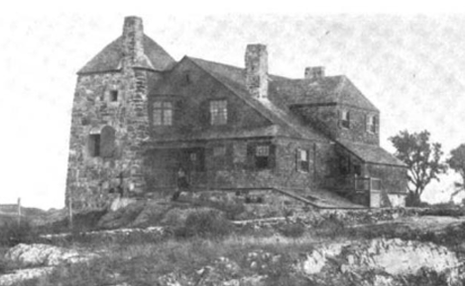

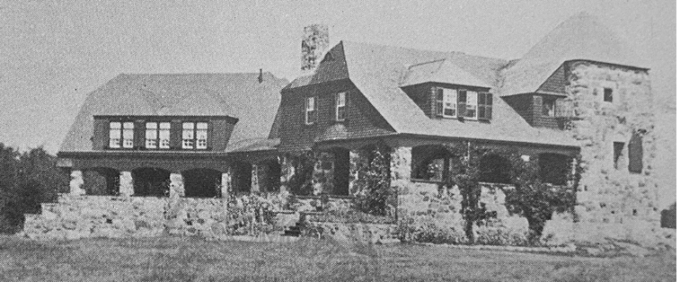
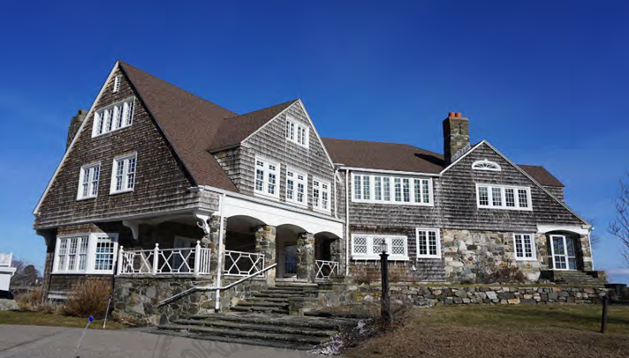

Location: 149 Wild Rose Lane, Newcastle, New Hampshire.
Built: : 1883, expanded 1931.
Architects: Edmund M. Wheelwright and William A. Bates later William L. White.

Architects
Edmund M. Wheelwright (1854–1912) was a Boston architect educated at Harvard, MIT, and the École des Beaux-Arts in Paris. After early work with Peabody & Stearns and McKim, Mead & White, he developed a practice that combined academic training with picturesque design. His 1883 house for Edmund Clarence Stedman (Kelp Rock) is a notable early Shingle Style work, distinguished by rugged stone construction, irregular massing, and a dramatic coastal siting. Wheelwright later served as Boston City Architect and designed many major public buildings, though Kelp Rock remains one of his most imaginative domestic commissions.
William A. Bates (1853–1922) was a New York architect best known for suburban and resort houses and for his writings on domestic architecture. From 1896 to 1905 he oversaw the enlargement of Kelp Rock for William Van Duzer Lawrence, nearly doubling the house while preserving its Shingle Style character. Bates echoed Wheelwright’s arched stone porticos, shingled surfaces, and asymmetrical massing, transforming the cottage into a substantial Gilded Age summer estate without stylistic rupture.
William L. White (1885–1971) was a New Hampshire architect trained at Harvard and in the offices of Olmsted Brothers, Cram & Ferguson, and Mowll & Rand. Beginning around 1930, he specialized in modernizing older houses to suit contemporary tastes. His c.1931 redesign removed the stone tower and regularized rooflines and dormers, imposing a Colonial Revival order on the earlier Shingle Style composition. The resulting house, renamed Beacon Rock, reflects White’s characteristic emphasis on formality and architectural coherence.

Architectural Description
The house at 149 Wild Rose Lane is a layered seaside residence reflecting three principal building campaigns: the original 1883 Shingle Style cottage by Edmund M. Wheelwright; the c.1896–1905 expansion for William Van Duzer Lawrence; and the c.1931 Colonial Revival transformation by William L. White.

Phase I (1883). The original house, built for Edmund Clarence Stedman and known as Kelp Rock, was a compact 1½-story Shingle Style cottage dramatically sited on rocky ledges overlooking Portsmouth Harbor. Wheelwright’s design combined a high stone base, arched stone loggia, shingled upper walls, and a distinctive two-story stone tower at the northeast corner. Irregular rooflines with clipped gables and dormers reinforced the picturesque character, while the plan centered on a combined hall–living room with the study located in the tower.
Phase II (c.1896–1905). After acquiring the property in 1896, William Van Duzer Lawrence nearly doubled the house in size under the direction of architect William A. Bates. A substantial 2½-story westward addition expanded the house into a full-scale summer estate. Bates retained the Shingle Style vocabulary—arched stone porticos, shingled walls, and irregular massing—allowing the enlarged structure to remain visually continuous with Wheelwright’s original cottage.
Phase III (c.1931). In the early 1930s, architect William L. White undertook a comprehensive redesign that imposed a Colonial Revival order on the earlier picturesque composition. The stone tower was removed, clipped and jerkinhead roofs were replaced with steep gables, and dormers were simplified and regularized. While much of the original rugged character was subdued, first-floor stonework and portions of the arched porticos were retained, preserving elements of the earlier phases beneath the Colonial Revival overlay.
Present Appearance. Today the house is a 2½-story stone-and-shingle residence in which the eastern core of the 1883 cottage, the westward Lawrence-era addition, and the unifying 1930s Colonial Revival treatment remain legible. Although later alterations softened the original Shingle Style boldness, the building clearly illustrates the evolution of a late nineteenth-century artistic retreat into a formal twentieth-century seaside estate.
History
The house at 149 Wild Rose Lane, New Castle, New Hampshire, was built in 1883 as a seaside summer cottage for Edmund Clarence Stedman (1833–1908), one of the most influential American literary critics of the late nineteenth century. Designed by Boston architect Edmund M. Wheelwright, the house—known as Kelp Rock—became a well-known gathering place within the Little Harbor summer colony, attracting writers and intellectuals drawn to the New Hampshire seacoast. Widely published in architectural and popular journals, the house gained early recognition for its dramatic siting and unconventional design.

In 1896, following financial difficulties, Stedman sold the property to William Van Duzer Lawrence (1842–1927), whose ownership marked the most consequential phase in the estate’s development, transformed the former literary retreat into a substantial Gilded Age summer estate. Over the next nine years he nearly doubled the size of the house, acquired additional land, and invested heavily in renovations that adapted the property for large-scale social use while retaining its Shingle Style character.
Lawrence sold the property in 1905, but the enlarged house he created defined its subsequent scale and function. In the early 1930s, a major redesign by architect William L. White altered the exterior, removing the distinctive stone tower and imposing a more formal Colonial Revival character. Following this transformation, the property came to be known as Beacon Rock.

Kennedy Family: Origins, Character, and Legacy

Origins and Migration
The Kennedys were a Scots family who went first to Ireland and then to North America. The most probable account of their migration—though it contains a romantic element—is that given by Eliza Smith Brown in She Devils at the Door:

“For the Kennedy family, the initial foray from Ulster to Pennsylvania had been made by Bailey Kennedy in 1752. Born in 1730, Bailey had worked as a coachman on the estate of Samuel Stewart and his wife Mary.... The two twenty-two-year-olds fell in love, a decidedly unfavorable match for the daughter of a noble family. Seeking to squelch the romance, the Stuarts put Moor ‘in confinement’... When Bailey learned of their plans, he secreted Moor away in the night and galloped with her on his horse to a nearby seaport, where his possessions were waiting in a large trunk, and they boarded a ship for America. By the time the family learned of the plan and rushed to the harbor the next morning, the ship was disappearing on the horizon, and by the time they landed in Philadelphia, the runaways were married.” (She Devils at the Door, p. 24)

Early Settlement and Industrial Expansion
The Kennedys moved westward to Ohio—then part of the Connecticut Western Reserve—and later to Pittsburgh. They became significant in the development of the iron and steel industries of Ohio, Pennsylvania, and New York, and indeed of the modern industrial world. To this day, many descendants of Julian Kennedy are engineers.

In contrast to the more flamboyant New York families connected to the Lawrences, the Kennedys were sober, practical, and rooted in the disciplines of farming, engineering, and law. Their lives reflected a habit of order and restraint. They were generally long-lived, seldom divorced, and occasionally ventured into politics, almost always as Republicans.

Scots Virtues: Thrift, Order, and Discipline
The Kennedys exhibited the traditional Scots virtues of thrift, discipline, and efficiency. Julian Kennedy exemplified these traits, seeking to maximize the output of furnaces while minimizing raw materials and energy.

- His daughters inherited this zeal, waging decades-long battles against governmental waste and, at times, against their brothers over inheritance. In the Kennedy Estate Controversy, for example, the sisters successfully leveraged the legal doctrine of estoppel by acquiescence—insisting that adherence to legal and financial fact (tax filings) superseded any subjective, informal family understanding.
- Julian Kennedy and his descendants represented a now-vanished American type: energetic, ethical, and confident Mainline Protestants who believed that competence, moral order, and civic virtue could build a just society.

Religious Evolution and Public Morality
Though Presbyterian in youth, Julian later joined the First Unitarian Church, where he and his wife supported what was then called “Liberal Religion.” The term meant non-dogmatic, not permissive: a faith grounded in reason and duty. Their morality was non-denominational but traditional, shaped by a belief in service and integrity.

The Kennedys supported women’s suffrage both from fairness and from conviction that women’s votes would oppose social evils—war, drunkenness, prostitution—that undermined family life. Reformers like Lucy Kennedy saw firsthand how legislators resisted raising the age of consent. Outraged by such moral blindness, Lucy denounced the Pittsburgh mayoral candidate Babcock for defending prostitution, and confronted the Episcopal bishop who refused to withdraw his endorsement of him. Both in England and America, the nineteenth century saw the gradual criminalization of “characteristically male vices,” and the Kennedys were part of this movement, insisting that public life should reflect private virtue.

Engineering Genius Applied to Civic Life
Julian Kennedy’s engineering genius lay in his ability to visualize the entire system of iron and steel production—how each machine interacted with the next—and to design for maximum yield with minimum waste. His daughters Lucy and Eliza applied this same principle to civic life: a government or business should produce the greatest good with the least cost. To that end, they studied the mechanics of politics from the ballot box through the labyrinth of municipal bureaucracy.

For the Kennedys, efficiency was never merely mechanical; it was moral. Competence, they believed, was the foundation of justice. They organized women to attend rape trials, ensuring that victims would see sympathetic faces in the courtroom. Their activism arose from conviction that competence and compassion were inseparable.

Civic Reform in Pittsburgh
The Kennedy sisters were particularly alarmed by the consequences of governmental incompetence. During the early 1950s, after a series of brutal murders of women and girls, police officers (often political appointees without training) responded hours late to calls. In one case they overlooked the victim’s body on a nearby lawn.
Lucy and Eliza Kennedy led campaigns for reform—calling for professionalized police forces, merit-based hiring, and modern investigative infrastructure. Their efforts helped lay the groundwork for later reforms in Pittsburgh’s civic administration.

Kinship and Legacy
The Kennedy and Lawrence families were joined by the marriage of Kennedy Smith (1922–1996) to Mary Elizabeth Rutter (1920–2003), a descendant of William Lawrence (1622–1680). Through this union, the industrious moralism of the Kennedys blended with the cosmopolitan energy of the Lawrences, linking two of the most distinctive traditions in American family history.

Kennedy Family’s Estate Dispute
Background
When Julian Kennedy (1852–1932) died, he left an estate of approximately $700,000—about $15 million in 2025 dollars. The distribution of the estate became the subject of bitter litigation among his four surviving children. Attorneys John Freeman represented the brothers, Joseph W. Kennedy and Julian Kennedy, Jr., while Charles F. C. Arensberg represented the sisters, Mrs. R. Templeton Smith (Eliza Kennedy) and Mrs. Hugh O. Miller (Lucy Belle Kennedy).

The brothers claimed entitlement to $185,000 based on a 1918 business agreement with their father, under which Joseph was to receive an annual salary of $7,500 and Julian Jr. $6,000, each sharing one-third of the profits in their father’s engineering firm, Julian Kennedy, Engineer. Freeman contended that this arrangement was not a partnership and that the sons were not liable for any of the firm’s losses.

Arensberg, on behalf of the sisters, countered that the brothers “could not receive all the benefits and none of the burdens.” He noted that they had filed partnership income tax returns and “took the losses on their individual income tax returns which they now seek to collect from the estate.”

Domestic and Property Disputes
Beyond the business claim, the division of extensive real property caused further conflict. The brothers wished to maintain the Kennedy house and estates intact; the sisters objected to the expense.

Mrs. Miller testified: “We specified objections to the house being kept open because we thought it was not necessary, and we objected to bills being paid unless we were consulted and had the opportunity to get bids for ourselves because there were always bills coming in and we didn’t even know anything had happened and we were asked to pay.”

The Pittsburgh Press observed that “the women disagreed over everything done, even to a bill of $15.65 for a leaking water pipe.” Mrs. Miller described the repairman as “a very high charger,” complaining that “he wiped a joint and he didn’t wipe it very lastingly. Someone else had to come in and do it again.”

Even domestic matters—such as “the use of electricity to run the vacuum sweeper”—became points of contention.

Julian Jr. further complicated matters by promising his dying mother to care for long-time household employees, Frank Luther and his family, and the maid Mrs. Nora Durkin. The sisters vehemently opposed paying them from the estate.

Lower-Court Proceedings
The Orphans’ Court ruled for the sisters, rejecting the brothers’ $185,874 claim for reimbursement of business losses. The brothers appealed. In March 1935, the Supreme Court of Pennsylvania affirmed the lower court’s decision and ruled that the real property should be divided among the siblings. The 25-room Kennedy mansion, next to the W. L. Mellon estate, was sold in 1936 and subsequently demolished when Mellon purchased the property to enlarge his own grounds.

Key Findings of the Supreme Court
The Court summarized the dispute: “On March 19, 1918, Julian Kennedy, a construction engineer of Pittsburgh, entered into a written agreement with his two sons, Joseph W. Kennedy and Julian Kennedy, Jr.… This agreement continued in force for more than fourteen years, until terminated by the father’s death on May 28, 1932. Thereupon the sons filed a claim against his estate in the amount of $185,874.83.”

The Court reviewed the facts: “The business continued to be conducted solely in the name of Julian Kennedy, Engineer, and under his direction.… The funds of the business were kept in his personal account.… Profits were earned each year from 1918 to 1926; thereafter, for five years, losses were sustained each year, which, in like manner as the profits, were equally divided.… The total losses so charged to each of the sons amounted to $64,751.91.”

The brothers argued that they were unaware of these bookkeeping entries and had not consented to bearing losses. The Court rejected this contention, citing their own tax filings:“It is admitted of record that ‘Joseph W. Kennedy and Julian Kennedy, Jr., each included in their personal income tax returns as a deduction one-third of the losses of the business carried in the name of Julian Kennedy, Engineer, for the years 1927 to 1931.’ … This evidence cannot be ignored or controverted. It shows that the two sons not only were cognizant of the proportionate sharing of losses, but that they acquiesced in this method of dividing them.”

Court’s Reasoning
The justices held that the sons’ conduct for five years demonstrated full acceptance of the losses and barred them from asserting new claims after their father’s death:
“The time to have raised the question now before us was during the lifetime of Julian Kennedy, Sr., not after his death.… Having acted for a period of years upon the understanding that they were chargeable with a share of the losses, the sons are now estopped from obtaining from the estate of their father reimbursement for losses which they assumed and paid voluntarily during his lifetime.”

Quoting prior precedent, the Court emphasized the doctrine of acquiescence:
“An estoppel may be raised by acquiescence, where a party aware of his own rights sees the other party acting upon a mistaken notion of his rights.… When a party with full knowledge remains inactive for a considerable time… the transaction, although originally impeachable, becomes unimpeachable.” (Phila. R. C. I. Co. v. Schmidt, 254 Pa. 351 (1916))

Finally, the Court concluded that even if the sons had misunderstood their legal rights, they could not recover:

“Even if it be conceded that appellants made no protests against the charges because they were mistaken as to their rights under the terms of the agreement, they are then in no better position.… Their mistake, if any mistake existed, concerned the legal construction of the agreement.… This was a mistake of law, and it is a firmly-settled rule that one who has voluntarily paid money with full knowledge of all the facts cannot recover it back by reason of a mistake or error as to the applicable rules of law.”

The decree was therefore affirmed, with costs assessed against the appellants.

Aftermath
The Supreme Court’s decision permanently ended the Kennedy estate dispute. The brothers’ claim of $185,874.83 was denied; the sisters prevailed in maintaining equal division of their father’s estate. The case became a Pennsylvania precedent illustrating estoppel by acquiescence and the limits of posthumous claims against estates arising from long-standing family business arrangements.

Legal Legacy of the Kennedy Estate Case
Case Citation: In re Estate of Julian Kennedy, Supreme Court of Pennsylvania, 1935.
Key Principles: Partnership characterization, estoppel by acquiescence, mistake of law in voluntary payments, family-business fiduciary conduct.
Enduring Precedent on Acquiescence and Estoppel
The 1935 Kennedy Estate decision has been cited repeatedly in Pennsylvania jurisprudence for its articulation of estoppel by acquiescence. The Court’s statement—“Having acted for a period of years upon the understanding that they were chargeable with a share of the losses, the sons are now estopped from obtaining from the estate reimbursement”—became a controlling expression of the rule that silence or inaction over time may bar later claims, even among close relatives. Later courts invoked this language in Schneider v. Schneider (Pa. 1948) and Loboda v. United States (3d Cir. 1961), both reaffirming that a party who accepts benefits under a business arrangement cannot subsequently deny its burdens.
Family Partnerships and the Limits of Informality
The Kennedy case also stands as a cautionary example in estate law regarding “family partnerships.” The Supreme Court refused to allow familial informality to override clear, long-term financial conduct. By relying on the brothers’ consistent use of partnership tax returns, the Court held that subjective intent could not displace the objective financial record. This reasoning has influenced later decisions interpreting intra-family agreements, notably In re Estate of Hall (Pa. 1952) and Matter of Brown’s Estate (Pa. Super. Ct. 1974).
Mistake of Law vs. Mistake of Fact
In reaffirming the rule from Good v. Herr (1844) that money voluntarily paid under a mistaken view of the law is not recoverable, Kennedy clarified that sophistication of the payor increases responsibility. Because the Kennedy sons were “men of intelligence and business experience,” the Court denied relief based on supposed ignorance of legal interpretation. This reasoning continues to appear in Pennsylvania and federal opinions on restitution, voluntary payment, and family business disputes.
Historical Significance
Beyond its technical holdings, Kennedy’s Estate illuminates the tensions within early twentieth-century professional families—between paternal authority, filial loyalty, and modern notions of equity. Its enduring lesson is that moral fairness does not always align with legal finality: the brothers’ filial loyalty in accepting losses could not be rewarded by law after their father’s death.

Kennedy Family Business Network: From Furnace Builders to Finance and Reform
Overview
From the mid-1800s to the mid-1900s, the Kennedy family evolved from pioneer iron furnace builders in Ohio’s Mahoning Valley into a powerful kinship network spanning heavy industry, finance, and Progressive-era politics. Starting with founder Thomas Walker Kennedy’s practical metallurgical skills, the family expanded into global steel consulting, corporate management, and political influence. Their operations reached from Ohio and Pittsburgh to Chicago, Buffalo, Boston, and internationally to India, China, and Russia.

I. Founding Generation (Generation 1)
The network was built by three brothers who established the family’s technical and ministerial roots:
- Thomas Walker Kennedy (1824–1906): Founder. Built the first blast furnace in the Mahoning Valley, Ohio. All major industrial figures in the family trace back to his sons.
- John Reid Kennedy (1821–1869): Father of several industrial and legal cousins.
- David Stewart Kennedy (1834–1898): United Presbyterian minister. His sons later returned to the iron and steel industry.
Thomas Walker Kennedy’s Legacy By moving from farming to ironmaking, Thomas placed the family at the forefront of the Western Reserve’s industrial growth. His sons combined hands-on furnace experience with technical education (often at Geneva College), creating a distinctive “Kennedy school” of furnace managers and engineers.

II. Technical Expansion (Generation 2: Thomas Walker’s Sons)
Thomas Walker Kennedy’s seven sons spread the family’s metallurgical expertise across the growing U.S. and global steel industry:
- Julian Kennedy (1852–1932): Leading global consulting engineer. Served as superintendent at Carnegie’s Homestead Works. Founded a firm that designed furnaces and mills for U.S. Steel, Tata Steel in India, and projects across Europe.
- Hugh Kennedy (1856–1929): Iron executive and blast-furnace builder. Managed Carnegie operations and later served as General Manager of the Buffalo & Susquehanna Iron Company (whose plants were engineered by Julian).
- Walter Truesdale Kennedy (1861–1924): Superintendent of Carnegie’s Lucy Furnace. Later managed the Han Yang iron and steel works in China and served as First Secretary of the Imperial Railway in China (1890s).
- John Harrison Kennedy (1864–1945): Furnace manager in Steubenville and Punxsutawney, Pennsylvania. Later managed Rogers & Brown’s Susquehanna Furnaces in Buffalo.
- Samuel A. Kennedy (1867–1953): General Manager of Iroquois Iron in Chicago. Supervised construction of the Columbia Steel Plant in Provo, Utah (1920s), helping build western steel capacity.
- Thomas Walker Kennedy Jr. (1869–1962): Fuel executive. Managed Isabella Furnace, then became President of Mystic Iron Company and the New England Gas and Fuel Company.
- James Kennedy (1853–1928): U.S. Congressman from Ohio. Advocated protectionist tariffs to support the American iron and steel industry.

III. Integration and Expansion
A. Carnegie–Homestead Cousins A parallel branch of cousins (from Thomas Walker’s brothers) held key roles in the Carnegie steel empire, linking shop-floor work, unions, management, and local politics:
- Reid Kennedy (1864–1953): Steelworker and union leader (served on the 1892 Homestead Strike Advisory Committee). Later became Burgess of Homestead, founding president of Monongahela Trust Company, and treasurer of Orient Coke Company (with Julian Kennedy as president).
- David Stewart Kennedy (1861–1919): Superintendent of structural mills at Carnegie’s Homestead. Later Burgess of Munhall and member of the Pennsylvania House of Representatives.
- Harry David Kennedy (1863–1925): Blast-furnace superintendent for Carnegie, Donner Steel, and the Nikopol-Mariupol Mining & Metallurgical Company in Ukraine’s Donbas region.
B. Coal, Capital, and the Mellon–Frick Connection The family strengthened its industrial position through strategic marriages into the fuel sector:
- Raymond Templeton Smith (husband of Eliza Kennedy Smith): Executive Vice President of Pittsburgh Coal Company (tied to Mellon–Frick interests). This connection secured coal supplies for the furnaces the Kennedys designed and managed.
- Orient Coke Company: Joint venture with Reid Kennedy as treasurer and Julian Kennedy as president. Gave the family a direct role in the coke supply chain feeding Pittsburgh’s steel mills.
C. Finance and Institutional Roles The network extended into banking and capital:
- Monongahela Trust Company: Founded and led by Reid Kennedy; provided regional industrial financing.
- Other family members, including Samuel A. Kennedy, served on bank boards (e.g., First Security Bank in Salt Lake City) and participated in regional planning, such as water districts critical for western coal and steel development.

IV. Legacy: Technical Ethics and Progressive Reform
The Kennedy network uniquely combined industrial power with Progressive reform:
- Engineering in Government: Julian Kennedy’s daughters, Lucy Kennedy Miller and Eliza Kennedy Smith, applied their father’s engineering principles (maximizing efficiency and minimizing waste) to municipal government.
- Suffrage and Anti-Corruption: They were leaders in Pennsylvania’s suffrage movement (Lucy led the Equal Franchise Federation) and campaigned against political corruption and vice, helping lead to the indictment of Pittsburgh Mayor Charles H. Kline in the 1930s.
- Civic Accountability: In the 1950s, they pushed for professionalizing Pittsburgh’s police force and modernizing its investigative systems, stressing that competence and moral integrity were essential to justice.
Overall Legacy
The Kennedy family started as furnace builders in Ohio and grew into a transatlantic network of heavy industry, finance, and corporate management — while also producing some of Pennsylvania’s most determined political reformers.

Kennedy House at 5400 Forbes Avenue

Location: 5400 Forbes Avenue (often listed as Forbes Street in early records), Pittsburgh, Pennsylvania, on a four-acre site overlooking Schenley Park, near Darlington Road.
Built:
Architect: Gorge Orth.

Architect
George Orth (1843–1918), often practicing as George S. Orth and later in partnership with his brother Alexander Beatty Orth as George S. Orth & Brother (from about 1900), was a prominent Pittsburgh architect whose career was closely tied to the city’s late-nineteenth- and early-twentieth-century industrial elite. He was especially known for designing substantial urban mansions and country houses, along with selected institutional buildings, in the eclectic idioms then favored by wealthy clients, including Queen Anne, Colonial Revival, and French Renaissance Revival styles. Among his most important works were the houses of Colonial Place in Shadyside, the French Renaissance Revival William Penn Snyder House in Allegheny West, and Wilpen Hall in Sewickley Heights, as well as major residences on Brighton Road and institutional commissions such as the School for Blind Children in Oakland.

Architecture and Description
The house was a 28-room mansion constructed of hand-cut native sandstone. Contemporary descriptions emphasized the exceptional quality of materials and workmanship. The interior featured extensive oak paneling, hardwood floors, and mahogany ceiling beams, all noted as being in excellent condition at the time of sale. Trim work was executed in walnut and bird’s-eye maple. Family tradition held that the structure, like the industrial plants Kennedy designed, was massively over-engineered.
Occupancy and Social History
Julian Kennedy and his family occupied the house until his death. During their residence, the mansion functioned as a center of social and political life. The Kennedy household was closely associated with progressive causes, including women’s suffrage, and the house hosted prominent national reform figures. Julian’s wife Jennie Kennedy and their daughters, including Eliza Kennedy Smith and Lucy Kennedy Miller, were active in these movements.
Later History and Demolition
Following Julian Kennedy’s death, the property became subject to a family partition action and was sold in the late 1930s. One contemporary report cites a sale price of approximately $38,700 for the residence parcel. The purchaser was W. L. Mellon, who owned the adjacent estate. Mellon demolished the mansion in order to incorporate its grounds into his property. According to family lore, the building’s heavy construction required the use of dynamite for demolition.
Demolition contractors advertised the sale of salvaged materials, underscoring the scale and quality of the stone and interior woodwork. The original four-acre site was later subdivided.
Present Site
Today the former grounds of 5400 Forbes Avenue are occupied by a small group of post–World War II houses along Darlington Road overlooking Schenley Park. No visible trace of the Julian Kennedy mansion survives.

Kennedy, Archie Goodwill (1866–1943)
Judge
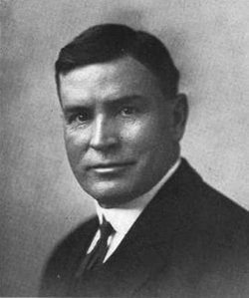

Parents: David Stewart Kennedy (1834–1898) and Nancy Wills Kelly (1837–1921).
Married: Katherine Herine Fuller (1870–1949).
Children: None recorded.
Kinship: First cousin three times removed of the post–World War II Smith generation.

Early Life and Education
Archie Goodwill Kennedy was born in Washington County, Pennsylvania, the son of a Presbyterian minister. In 1878 the family moved to Illinois, where Archie attended Sandwich High School and later the State Normal University at Normal. He graduated from Monmouth College in 1892 and began reading law under Judge Carnes in DeKalb, Illinois.
Legal Training and Career
Kennedy was admitted to the bar in 1894 and continued his studies at the Chicago Law School, from which he graduated in 1899. His early legal work reflected both energy and ambition. He served as city attorney for DeKalb and then as state’s attorney for DeKalb County from 1900 to 1904. Governor Charles Deneen later appointed him judge of the Illinois Court of Claims. A Republican, Kennedy also served twelve years as city judge. His tenure on the Cook County Circuit and Superior Courts was notable for his efficiency: he was credited with aiding in the disposition of approximately 4,000 cases.
Civic Involvement
Beyond his judicial work, Kennedy was active in civic life. He served as president of the DeKalb County Bar Association, as a member and later president of the DeKalb Township High School Board, and as a member of the local hospital board. He was also a charter member of the Salvation Army board and belonged to the Benevolent and Protective Order of Elks.
Religious and Personal Life
Judge Kennedy was a member of the First Congregational Church of DeKalb, Illinois, where he was an active supporter and from which he was buried in 1943. His life reflected the Midwestern blend of public service, religious conviction, and civic duty characteristic of his generation of professional men descended from the Scots-Irish Kennedys of Pennsylvania.

Kennedy, David Stewart (1834–1898)
Presbyterian Minister
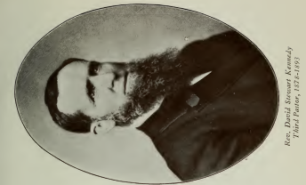

Parents: James Bailey Kennedy (1794–1873) and Sarah Reid (1792–1873).
Married: Nancy Wills Kelly (1837–1921).
Children: Sarah Elizabeth Kennedy (1860–1949); Bella M. Kennedy (1861–1891); Harry David Kennedy (1863–1925); Reid Kennedy (1864–1953); Archie Goodwille Kennedy (1866–1943); Mary Kennedy (1868–1906); James B. Kennedy (1871–1879); Tillie Kennedy (b. 1873); Annie Margretta Kennedy (b. 1876); Thomas Walker Kennedy (1881–1963).
Kinship: Great-granduncle of the post–World War II Smith generation.
Education
David Stewart Kennedy entered Westminster College in New Wilmington, Pennsylvania, at age twenty-two and graduated in 1858, in the same class as his future wife, Nancy Kelly. He then attended Allegheny (Western) Theological Seminary in Allegheny City, now Pittsburgh Theological Seminary, completing his studies in 1862.
Civil War Era
Church histories of his later Illinois pastorate record that Kennedy served as a chaplain during the Civil War before accepting his first pastorate. Although the exact regiment is not identified, his seminary class produced many Union chaplains, and his subsequent service pattern fits the movement of western Pennsylvania clergy into wartime ministry.
Pastorates
Kennedy’s first charge was at Center, Washington County, Pennsylvania, where he remained for ten years. He then served the Sewickley congregation in the Presbytery of Allegheny for six years. In 1878 he accepted a call to the Somonauk United Presbyterian Church in DeKalb County, Illinois, and was installed there on September 5, 1878. He ministered faithfully for a little more than fifteen years, resigning in 1893 because of failing health.
Later Life and Death
After resigning, Kennedy retired to his farm near Somonauk. He died in 1898 and was buried with his wife in Oak Mound Cemetery. Church and cemetery records confirm his service dates and burial site.
Assessment
Kennedy’s career reflects the westward progress of nineteenth-century Presbyterianism: rigorous theological training, early service in Pennsylvania, and the establishment of new congregations in the developing Midwest. His long Illinois pastorate and Civil War chaplaincy gave him regional influence. His children continued the family’s tradition of public service, most notably Judge Archie Goodwille Kennedy.

Kennedy, David Stewart (1861–1919)
Member, Pennsylvania House of Representatives
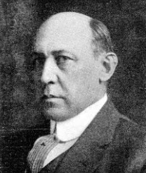

Parents: John Reid Kennedy (1821–1869) and Elizabeth Byrd (1829–1870).
Married: Mary Beazell (1873–1936).
Children: David Stewart Kennedy (1914–1978).
Kinship: First cousin three times removed of the post–World War II Smith generation.
Early Life and Education
David Stewart Kennedy was born February 15, 1861, in Youngstown, Ohio. He was educated at Poland Seminary, a preparatory school known for its strong classical curriculum and civic-minded ethos.
Career
Kennedy entered the furnace business at Hazelton, Ohio, later moving to Struthers, Ohio, and then to the Isabella Furnace in Etna, Pennsylvania. He rose steadily through the iron and steel industry and eventually became superintendent of the structural mills of the Carnegie Steel Company at Homestead.
In addition to his industrial career, Kennedy held numerous business appointments. He was president of the Reno Brothers Paint Company, secretary-treasurer of the Homestead Realty Company, and a director of both the Monongahela Trust Company and the Homestead Lumber Company.
Public Service
Kennedy was Burgess of Munhall, Pennsylvania, and served as a member of the Pennsylvania House of Representatives for Allegheny County during the 1913 legislative session. He was active in civic reform and was serving as president of County Draft Board No. 7 of Homestead at the time of his death in 1919.
Religious and Community Involvement
Kennedy was an elder in the United Presbyterian Church and known for his philanthropy in local education and church work. His leadership reflected the practical Presbyterian values of integrity and public service shared by many members of his extended family.
Death
He died July 10, 1919, in Pulaski, Lawrence County, Pennsylvania, and was buried in Poland Riverside Cemetery, Poland, Mahoning County, Ohio.
Family Note
His wife, Mary Beazell Kennedy, organized the Woman’s Suffrage Association of Homestead and Munhall with the assistance of Mrs. R. Templeton Smith (Eliza Jane Kennedy).

Kennedy, Eliza Jane (1889–1964)
Suffragist and Civic Reformer
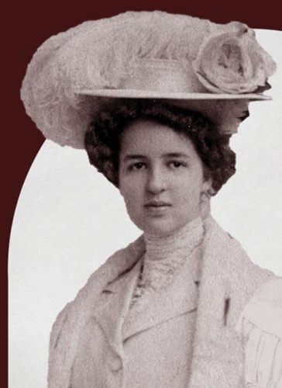

Parents: Julian Kennedy (1842–1932) and Jane Eliza Brenneman (1852–1930).
Married: Raymond Templeton Smith (1888–1967).
Children: Raymond Templeton Smith (1919–2007) and Kennedy Smith (1922–1996).
Kinship: Grandmother of the post–World War II Smith generation.
Early Life and Education
Eliza Jane Kennedy was born December 11, 1889, in Latrobe, Pennsylvania, the daughter of the prominent engineer Julian Kennedy and the suffragist and reformer Jane Eliza Brenneman Kennedy. In 1892 the family moved to Pittsburgh, where Eliza was raised in an atmosphere of public service and reform. She graduated from Winchester Thurston School in 1908 and from Vassar College in 1912 with a degree in economics and political science.
In 1907 she served as maid of honor at the wedding of her sister Lucy Kennedy to John Oliver Miller, an event held at the family home on Forbes Street in Pittsburgh. In 1915 she became engaged to Raymond Templeton Smith, a Cornell graduate and executive vice president of the Pittsburgh Coal Company. At her engagement party, her sister Lucy, president of the Equal Franchise Federation of Pittsburgh, called upon several guests to speak on women’s suffrage. Eliza married R. Templeton Smith later that year.
Suffrage and Civic Reform
Born into a family already committed to reform, Eliza joined her mother, Jennie E. Kennedy, and her sister, Lucy Kennedy Miller, in attending suffrage training sessions organized by Carrie Chapman Catt. The three women became active advocates for equal rights and female enfranchisement in Pennsylvania.
Eliza Kennedy Smith worked alongside Lucy Kennedy Miller, Jennie Bradley Roessing, Mary E. Bakewell, Hannah J. Patterson, and Mary Flinn Lawrence in organizing the Allegheny County Equal Rights Association. This organization evolved into the Equal Franchise Federation of Western Pennsylvania and, after the ratification of the Nineteenth Amendment in 1920, became the Allegheny County League of Women Voters. Eliza was elected president of the League in 1924 and held that position until her death in 1964.
Public Integrity and Government Oversight
In the 1930s Eliza and Lucy Kennedy Miller began investigating municipal corruption in Pittsburgh. Their work led to the indictment and conviction of Mayor Charles H. Kline on forty-eight counts of malfeasance. Eliza became widely known as “a relentless, tenacious watchdog of the city’s purse strings,” attending more budget hearings than any other citizen of her generation. She monitored the city’s use of funds, exposed abuses such as padded garbage collection weights, and demanded merit-based appointments in city departments.
During the 1940s she led the campaign to modernize the city’s police communications system after a series of unsolved murders revealed deficiencies in coordination and forensic capacity. Her advocacy resulted in the opening of a new centralized communications center in 1950.
Political Engagement and Later Years
A lifelong Republican, Eliza remained politically active into her seventies. In 1964 she and her granddaughter Eliza Smith appeared in The Pittsburgh Press with Admiral Ben Moreell as supporters of Senator Barry Goldwater’s presidential campaign. She and Moreell sought election as delegates to the Republican National Convention, pledging to support Goldwater on every ballot.
She and her husband maintained their home at 1336 Shady Avenue in Pittsburgh’s Squirrel Hill neighborhood.
Illness and Death
Diagnosed with carcinoma of the sigmoid colon in 1963, Eliza endured declining health over the following year as the cancer metastasized. She died at home on October 23, 1964, aged seventy-four. Funeral services were arranged by H. Samson Inc., and she was buried in Homewood Cemetery. Her son Kennedy Smith served as informant on her death certificate.
Legacy
Upon her death, The Pittsburgh Press and Post-Gazette honored her as one of the city’s most effective private citizens. On June 10, 1965, Congressman James G. Fulton entered a tribute to her into the Congressional Record, praising her as “one of our most honored citizens in the city of Pittsburgh … whose tireless efforts over the years gave so much toward improving the civic life and governmental structure of Pittsburgh.”
Her granddaughter, Eliza Smith Brown, later chronicled her life and work in She Devils at the Door (Carnegie Mellon University Press, 2023), which portrays the Kennedy sisters as emblematic of a generation of civic reformers who combined social conscience with administrative skill and moral determination.
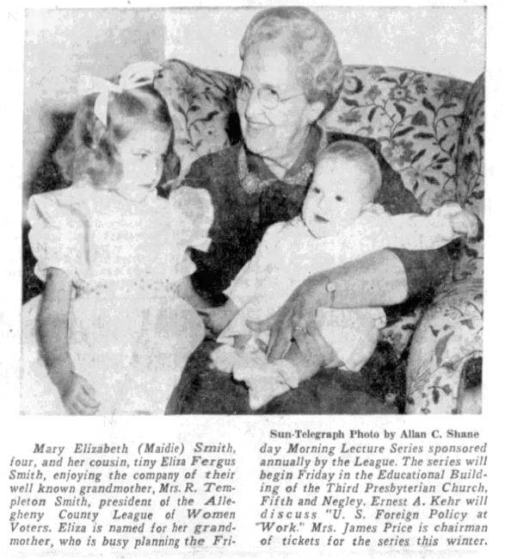

Kennedy, Harry David (1863–1925)
Blast Furnace Specialist

Parents: David Stewart Kennedy (1834–1898) and Nancy Wills Kelly (1837–1921).
Married: Mary M. Mayer (1875–1943).
Children: Elizabeth Nan Kennedy (1907–1970); Harry Kennedy (1908–1996); Mary Eleanor Kennedy (1913–1988).
Kinship: First cousin three times removed of the post–World War II Smith generation.
Early Life and Family
Harry David Kennedy was born April 24, 1863, in Pittsburgh, Pennsylvania. He passed away October 20, 1925.
Industrial Career
Kennedy began his career with Carnegie Steel in the Pittsburgh region, acting as a blast furnace superintendent. He then took charge of the Iroquois Furnace in Chicago under Rogers, Brown & Company, a major iron works firm in the Calumet district. Afterward he traveled abroad to Russia to operate the blast furnace of the Nikopol-Mariupol Mining & Metallurgical Company—a Donbas firm with American technical involvement founded by connections including his cousin Julian Kennedy.
Returning to the U.S., Kennedy supervised the Clairton furnace for Carnegie, later led blast furnace operations for Donner Steel, and finally oversaw the production of ferromanganese at Lavino Furnace Company in Sheridan, Pennsylvania.
Assessment and Context
Kennedy’s professional trajectory aligns with the movement of American furnace specialists across domestic and international sites during the Gilded and Progressive eras. The plants he is said to have managed—Carnegie’s Mon Valley furnaces, Iroquois in Chicago, Donbas operations, Lavino ferromanganese works—are well documented in industrial histories, and the overseas connections of his cousin Julian Kennedy lend credibility to his foreign assignment, though surviving trade directories and company records do not always list him by name.

Kennedy, Hugh (1856–1929)
Industrial Executive and Blast Furnace Innovator\

Parents: Thomas Walker Kennedy (1824–1896) and Margaret Truesdale (1824–1907).
Married: Elizabeth Smith (1858–1912).
Children: Roy Guthrie Kennedy (1880–1962); Julia T. Kennedy (1882–1975); George Walker Kennedy (1884–1951); Margaret Kennedy (1886–1959); Paul Reed Kennedy (1888–1958); John Smith Kennedy (1889–1971); Thomas Walker Kennedy (b. 1889); Rebecca Kennedy (1892– ); Ross Kennedy (1894– ); Rachel Kennedy (1895–1957); Elizabeth Kennedy (1898–1982).
Kinship: Great-granduncle of the post–World War II Smith generation.
Early Life and Transition to Industry
Hugh Kennedy was born in Mahoning County, Ohio. In his youth he farmed and taught in local schools. Later he turned to contracting and construction, developing expertise in blast furnace building. According to biographical sources, he is credited with inventing a method for controlling furnace blast by volume rather than pressure, an innovation that contributed to more stable furnace operation in the era before full instrumentation.
Industrial and Managerial Career
By 1880, Hugh became assistant to his brother Julian Kennedy within the Carnegie Steel Company, suggesting an early role in metallurgical supervision. According to AIME Yearbooks (1904–1910), Hugh Kennedy is listed as General Manager, Buffalo & Susquehanna Iron Co., with an address in Erie, N.Y.
Later he held the position of manager at the American Steel Hoop Company, a firm operating in the steel finishing sector (barrels, hoops, steel bands). In 1902 he relocated to Buffalo to become General Manager of Buffalo & Susquehanna Iron Co.—a major pig iron firm whose furnaces were originally engineered by Julian Kennedy. (Julian Kennedy’s involvement in the founding of that company’s furnace works is documented in engineering histories and industrial chronicles.
Civic, Financial, and Institutional Roles
Beyond industry, Hugh was active in banking and civic institutions. He served as Vice President of the Farmers’ and Merchants’ Bank of Sharpsburg, Pennsylvania, and as President of that community’s YMCA. He was a board member of the Allegheny County Workhouse, a trustee of Westminster College (New Wilmington, PA), and a trustee of the United Presbyterian Board of Publications in Pittsburgh. He was also a member of prominent social and civic clubs such as the Duquesne Club in Pittsburgh and the Buffalo Club. These roles reflect the common pattern of industrial executives in early 20th century Pennsylvania engaging in institutional and social leadership.
Assessment and Legacy
Hugh Kennedy’s career illustrates how members of the Kennedy industrial family spanned from hands-on furnace building into executive control of regional iron works. His listing in AIME as General Manager of B&S Iron provides independent confirmation of his industrial stature. The connection between his managerial roles (Buffalo & Susquehanna) and his brother Julian’s furnaces strengthens the plausibility of familial industrial coordination. His contributions to banking, religious, and educational institutions reflect common patterns of civic investment among Gilded Age industrialists.

Kennedy, James (1853–1928)
Congressman

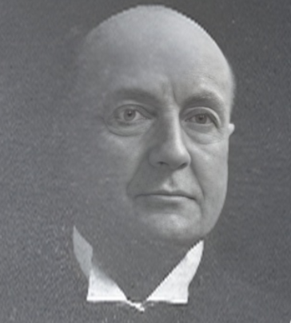
Parents: Thomas Walker Kennedy (1824–1896) and Margaret Truesdale (1824–1907).
Married: Phoebe Jane Irwin (1860–1923).
Children: Grace M. Kennedy (1890–1970).
Kinship: Great-granduncle of the post–World War II Smith generation.
Early Life and Education
James Kennedy was born September 3, 1853, in Lowellville, Mahoning County, Ohio. He prepared for college at Poland Union Seminary and graduated from Westminster College in New Wilmington, Pennsylvania, in 1876. He studied law and was admitted to the bar in March 1879.
Career in Law and Local Politics
Kennedy began practicing law in Youngstown, Ohio, where he also served on the city council from April 1886 to November 1888. He was active in Republican politics and in 1894 chaired the Republican State Convention at Steubenville.
Congressional Service
Kennedy was elected as a Republican to the Fifty-eighth and three succeeding Congresses (March 4, 1903 – March 3, 1911). He was known as a strong protectionist, arguing that reductions in tariffs caused widespread unemployment in Ohio’s manufacturing centers. In the House, he was a consistent supporter of Speaker Joseph Cannon and defended the party’s control of committee organization during the 1910 revolt against Cannon’s leadership.
Kennedy’s congressional record included attention to industrial policy, pensions, and the regulation of public lands. His floor statements emphasized that economic stability in the Mahoning Valley depended on steel and iron tariffs that protected domestic labor.
He was an unsuccessful candidate for reelection in 1910 and returned to the practice of law in Youngstown.
Later Life
In 1916 Kennedy joined the Democratic Party and ran unsuccessfully for Congress in 1926 as a Democrat. He continued his legal work until his death.
Death
James Kennedy died November 9, 1928, in Youngstown, Ohio, and was buried in Riverside Cemetery, Poland, Ohio.
Assessment
James Kennedy’s career reflected the trajectory of many late-nineteenth-century Midwestern Republicans—self-educated professionals whose political identity centered on industrial protectionism and civic order. His eventual shift to the Democratic Party illustrates the regional political realignments that followed the decline of the old industrial tariff consensus after 1912.

Kennedy, James Byrd (1862–1950)
Judge

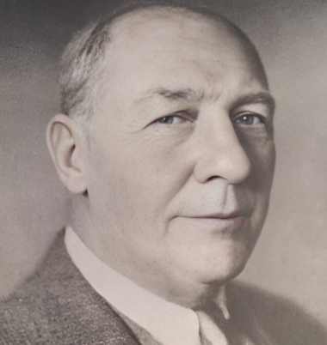
Parents: John Reid Kennedy (1821–1869) and Elizabeth Byrd (also Bird).
Married: (1.) Roxanna Rice (1860–1896); (2.) Mary Swift Young (1872–1959).
Children: With Roxanna Rice: Florence Byrd Kennedy (1889-1927) and Dudley Reid Kennedy (1886-1924); with Mary Swift Young: David Francis Kennedy (1891-1934).
Kinship: First cousin three times removed of the post–World War II Smith generation.

Early Life and Education
James Byrd Kennedy was born in Mahoning County, Ohio. Orphaned young, he and his brother were raised by their paternal grandfather. He attended schools in Coitsville and on Wood Street in Youngstown, and then studied at Poland, preparing for the classical department of the University of Michigan at Ann Arbor. Ill health forced his withdrawal within a year; after recovering he completed a commercial course at Duff’s Business College in Pittsburgh. While teaching school in 1882–1883 he read law, and he was admitted to the Ohio bar at Columbus in March 1885.
Law Practice and Public Office
Kennedy began practice in Youngstown and soon formed a partnership, becoming a familiar figure at the Mahoning County bar. A Republican, he was elected prosecuting attorney of Mahoning County in November 1890 and served six years. In 1896 he was elected judge of the Court of Common Pleas; he resigned from the bench in 1899 and returned to private practice with C. D. Hine at Poland, with offices in the Wick Building. Contemporary and retrospective sources confirm this career sequence.
Later Career and Community Ties
Kennedy remained active in practice for decades. Local records and Poland village documentation note his acquisition in 1923 of an eleven-acre estate in Poland, with subsequent subdivision and sales in the 1930s, reflecting his long residence and community standing.
Death and Burial
He died in 1950 and is commemorated locally as “Judge James B. Kennedy.”

Kennedy, John Harrison (1864–1945)
Blast Furnace Manager

Parents: Thomas Walker Kennedy (1824–1896) and Margaret Truesdale (1824–1907).
Married: Edith Hahn (1868–1946).
Children: Edith Barbara Kennedy (1895–1974); John Harrison Kennedy Jr. (1899–1974); Helen K. Kennedy (1905–1997).
Kinship: Great-granduncle of the post–World War II Smith generation.
Early Life and Education
John Harrison Kennedy was born on the family farm in Poland, Ohio. He completed preparatory studies and entered Geneva College, from which he earned a degree in chemistry in 1886.
Industrial Career
After college, he entered the iron and steel industry, managing blast furnaces in Steubenville, Ohio. On September 13, 1893, he married Edith Hahn in Allegheny City (now Pittsburgh’s North Side). By 1899 he was superintendent of the ironworks in Punxsutawney, Pennsylvania, a position confirmed by memorial records. (Find A Grave memorial notes this fact.) [turn0search0]
In 1912, John moved to Buffalo, New York, to manage the Susquehanna Furnaces of the Rogers & Brown Iron Company. His brother Hugh Kennedy was Vice President and General Manager of the same enterprise, making this a familial industrial alignment.
Later Years
By 1925, John had retired from active furnace management and taken residence in East Aurora Village, near Buffalo. His years thereafter seem to have been spent in retirement; his gravesite memorial indicates death in 1945. [turn0search0]
Assessment
John Harrison Kennedy’s professional life reflects the industrial mobility of late 19th / early 20th century American furnace men: chemical training, progression through superintendent roles, and eventual placement in a major metropolitan iron enterprise. His management of the Susquehanna Furnaces placed him at the heart of the Rogers & Brown expansion into western New York iron making.

Kennedy, Joseph Walker (1884–1950)
Consulting Engineer

Parents: Julian Kennedy (1852–1932) and Jane Eliza Brenneman (1852–1930).
Married: Katherine Browne Worcester (1885–1972).
Children: Joseph Walker Kennedy Jr. (1912–1993); Jane Kennedy (1914–2003); Worcester Kennedy (1915–1916); Winthrop Sargeant Kennedy (1918–1998); Katherine Worcester Kennedy (1921–1988); Abigail Kennedy (b. 1923).
Kinship: Granduncle of the post–World War II Smith generation.
Early Life and Education
Joseph Walker Kennedy was born in Pittsburgh, Pennsylvania, in 1884, one of the six children of the engineer and industrialist Julian Kennedy and Jane Eliza Brenneman. He attended Shadyside Academy and graduated from Yale University in 1905, entering the family’s engineering tradition that had produced some of the most notable blast furnace builders and designers of the early twentieth century.
Career
After completing his studies, Joseph joined his father’s firm, Julian Kennedy, Engineer, which designed and built furnaces, mills, and industrial plants in the United States, Europe, and Asia. He later worked as a consulting engineer in partnership with his father and his brother Julian Kennedy Jr. The firm’s engineering work was influential in the development of modern metallurgical plants and contributed to the expansion of steel production in Pennsylvania, New York, and abroad.
Following Julian Kennedy’s death in 1932, disagreements among the siblings over the settlement of the estate led to a prolonged legal dispute, known as the Kennedy Estate Controversy, which reached the Pennsylvania Supreme Court in 1935. The case, Kennedy’s Estate, clarified issues of partnership liability, business accounting, and inheritance among members of the family firm.
Religious and Civic Life
Joseph Kennedy was an active member of the First United Presbyterian Church of Oakland and a long-standing member of the Duquesne Club of Pittsburgh, reflecting his family’s social and professional prominence in early twentieth-century Pennsylvania.
Death
He died in 1950 and was buried in Homewood Cemetery, Pittsburgh, near his parents and siblings.
Assessment
Joseph Walker Kennedy represented the second generation of the Kennedy engineering dynasty. Educated and urbane, he maintained both the professional legacy and the civic connections of the family. His life bridged the transition from private industrial entrepreneurship to the more corporate, institutional milieu.

Kennedy, Julian (1852-1932)
World’s Foremost Metallurgical Engineer
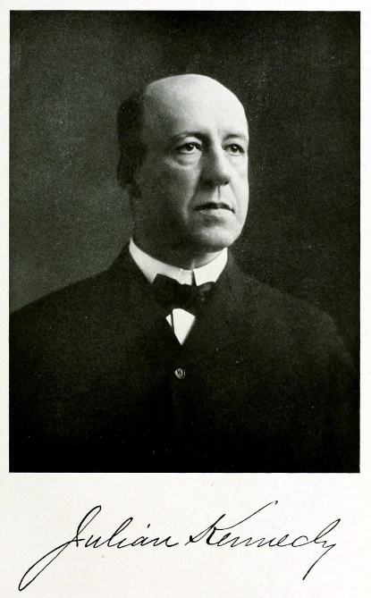

Parents: Thomas Walker Kennedy (1824-1896) and Margaret Truesdale (1824-1907).
Married: Jane Eliza Brenneman (1852-1930)
Children: Lucy Belle Kennedy (1880-1962); Joseph Walker Kenendy (1884-1950); Julian Kennedy (1886-1955); Hugh Truesdale Kennedy (1888-1889); Eliza Jane Kennedy (1889-1964); Thomas Walker Kennedy (1894-1922).
Kinship: Great-grandfather of the post-World War II Smith genration.

Early Life and Formation
Julian Kennedy was born on 15 March 1852 in Poland, Ohio, to Thomas Walker Kennedy and Margaret (Truesdale) Kennedy. His father, Thomas, was himself an engineer and furnace designer; Kennedy’s early exposure to blast-furnace practice came within this domestic environment.

He went to the Sheffield School of Science at Yale. After he graduated in 1875, he stayed to take graduate courses and to teach physics courses. He was also a champion sculler. He was stroke of the Yale Four-oared Crew at the Centennial in Philadelphia in 1876, won the single scull at Lake Saltonstall in 185, and the intercollegiate single scull race at Saratoga in the summer of 1876.
The WASP elites of America were concerned about the lack of masculinity and the neurasthenia of the upper classes. But Julian was an example of vigorous American masculinity. His physical attributes were measured and publicized:

“Julian Kennedy is the giant of the crew…. He is six feet tall, weighs 164, is forty-one inches around the chest, fourteen-inch biceps and twelve and a half forearm. He is a Western farm boy from Struthers, O,, florid and robust, with light hair and a quick eye.”
Kennedy married Jane Eliza (“Jennie”) Brenneman in 1878, with whom he had daughters Lucy and Eliza, both later prominent in Pittsburgh civic and suffrage movements.^

Superintendent and Chief Engineer
Kennedy’s first significant appointments were in bridge and steel works in the 1870s. By 1879 he was superintendent at Morse Bridge Works in Youngstown, Ohio, where he gained experience in heavy fabrication. In 1883 he moved to Pittsburgh, where he entered the Carnegie system at a moment of rapid consolidation and modernization.

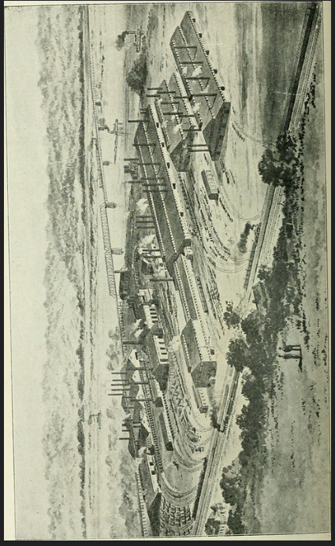

From 1885 to 1888, Kennedy served as general superintendent at the Homestead Works, then the centerpiece of Andrew Carnegie’s empire. At Homestead he participated in the planning and design of new open-hearth and armor-plate mills. As historians of the Carnegie company note, “Julian Kennedy drew up plans for an armor plate mill” during this period, work that directly fed into the United States’ naval rearmament program of the late 1880s and 1890s. Instead of making steel ingots and bars, which had to be sold as mere raw material, the Homestead works began to produce beams, girders, and all manner of structural shapes. At that start there was no strong demand for such things, but then America began building skyscrapers, and vast wealth flowed into Carnegie’s pockets. His role placed him among the select group of Carnegie “lieutenants” who bridged process knowledge and strategic industrial expansion.

Consulting Engineer
Julian did not find Carnegie’s style agreeable (see The Carnegie Boys: The Lieutenants of Andrew Carnegie that Changed America, Quentin R. Skrabec, Jr., 2012). Julian set himself up as a consulting engineer, worked at Allegheny Steel Works and Latrobe Steel Works, and soon became known as the best metallurgical engineer in the world.

He had scores of patents for devices and processes to improve iron and steel production, but his genius seems to have been in his ability to see the whole process as a single system, rather than as disparate machines, and to maximize the output of iron and steel while minimizing the input of ore and energy. That is, he was making the system as efficient as possible, a theme we will see in other family members.

Kennedy was deeply engaged in the professional networks of Pittsburgh engineers. He became an active member of the Engineers’ Society of Western Pennsylvania (ESWP), an organization that served as a clearinghouse for industrial practice in the nation’s steel capital. In 1907–08, he presented a paper entitled “Some Modifications in Blast Furnace Construction”, which appeared in the Proceedings of the society.

The paper dealt with improvements in furnace shells, stove connections, and refractory linings. Kennedy emphasized the “systemic” nature of furnace design: every modification to the stoves, gas mains, or charging equipment had cascading consequences for efficiency. His emphasis on plant-wide integration aligned him with contemporaries who increasingly treated the steel works as a holistic, interdependent organism rather than a collection of discrete machines.

In 1892, Frick and Julian toured the Homestead works after the violent strike, presumably to see what damage had been done to the equipment. Rumors circulated that Julian was being offered the superintendency of the plant, because he was acceptable to the workers. Whether or not this happened, Julian did not become superintendent again but pursued his consulting business.

Patents and Inventions
Kennedy’s technical contributions are best measured through his prolific patenting activity. Between the 1880s and 1910s, he secured dozens of U.S. patents focusing on hot-blast stoves, flue structures, charging mechanisms, and furnace valves.

A representative example is his 1903 application for a hot-blast stove (granted in 1904), which refined the cyclic process of heating and delivering air to the furnace. He aimed to increase thermal efficiency by improving gas flow within the stove’s checkerwork.

In 1916, Kennedy patented a flue structure for hot-blast stoves, introducing innovations in refractory design and gas distribution channels.^9 That same year, he secured a patent for a charging-bell apparatus, an attempt to regulate burden materials at the furnace top while maintaining internal pressure.

These inventions addressed two perennial problems in ironmaking: first, how to maximize heat recovery and minimize refractory damage in stoves; and second, how to maintain reliable, sealed, and controlled charging at the furnace top. Even incremental improvements in these domains could yield substantial savings in coke consumption or improvements in furnace output. Kennedy’s devices, therefore, were not merely mechanical curiosities but essential contributions to the economic competitiveness of large-scale steelmaking.

Professional Societies and Publications
Kennedy was deeply engaged in the professional networks of Pittsburgh engineers. He became an active member of the Engineers’ Society of Western Pennsylvania (ESWP), an organization that served as a clearinghouse for industrial practice in the nation’s steel capital. In 1907–08, he presented a paper entitled “Some Modifications in Blast Furnace Construction”, which appeared in the Proceedings of the society.

The paper dealt with improvements in furnace shells, stove connections, and refractory linings. Kennedy emphasized the “systemic” nature of furnace design: every modification to the stoves, gas mains, or charging equipment had cascading consequences for efficiency. His emphasis on plant-wide integration aligned him with contemporaries who increasingly treated the steel works as a holistic, interdependent organism rather than a collection of discrete machines.^12
The ESWP platform allowed Kennedy to situate himself among Pittsburgh’s technical elite—figures like Benjamin Thaw, William Metcalf, and the younger Charles Schwab—thus reinforcing both his professional credibility and civic stature.

Recognition and the ASME Medal
By the 1920s, Kennedy was recognized as one of Pittsburgh’s “eminent engineers.” In 1928, the American Society of Mechanical Engineers (ASME) awarded him the ASME Medal, citing his “eminently distinguished engineering achievement.”^13 The roll of medalists places him in the company of Wilfred Lewis (1927), W. L. R. Emmet (1930), Albert Kingsbury (1931), and Willis Carrier (1934).

This recognition, bestowed at the end of his career, acknowledged not only his inventions but also his international consulting. Kennedy had become known for designing entire works, integrating hot-blast stoves, charging mechanisms, and material-handling systems into coherent plants. The ASME award thus represented a codification of his reputation as an engineer who linked invention, plant design, and global diffusion of American practice.

International Consulting

Britain
By the early 1900s, Kennedy’s consulting firm, Julian Kennedy, Sahlin & Co., was active in Britain. He supervised refitting projects that adapted American design principles—larger furnaces, higher-pressure blast systems, and mechanical burden handling—to British works.^14 His ability to transfer these “American lines” of operation earned him contracts in an industrial environment increasingly conscious of U.S. competition.

Russia
In 1893 Russian princes visited Pittsburgh to meet Julian, and in 1896 Julian went to St. Petersburg and in 1897 to Mariupol. His nephew Harry Kennedy was the on-site supervisor. Julian seems to have been concerned with worker safety, and overbuilt his works to protect workers, and also, as it turned out, to protect Ukrainian soldiers from Russian artillery. The steel works at Mariupol withstood a siege for months in 2022, and finally the defenders evacuated.

India and the Tata Steel Works
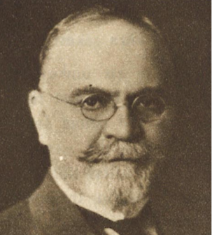
Kennedy’s most consequential foreign work came through his connection with Jamsetji Nusserwanji Tata, the Indian industrialist who envisioned a modern steel industry in India. During Tata’s 1902 visit to the United States, he consulted Kennedy in Pittsburgh about his plans. Kennedy advised Tata to begin with a thorough geological and market survey and recommended Charles Page Perin, a New York consulting engineer, to lead the investigations.

By 1907, Kennedy’s firm, in partnership with the Swedish-born engineer Axel Sahlin, was appointed construction engineer for the new Tata Iron and Steel Company (TISCO) at Jamshedpur. Sahlin had supervised the steel mill at Sparrows Point in Maryand. But Julian also went to India, and came back with trunks of Indian tsochkes, which have circulated in the family for over a century.

Kennedy, Sahlin & Co. designed the blast furnaces, hot-blast stoves, and open-hearth facilities, embedding U.S. technical practice in the new works. Contemporary sources credit Kennedy’s designs with giving the plant a competitive edge by ensuring high capacity, reliable stoves, and mechanized charging systems.

The Tatas, a Parsee family in India, had made a fortune in cotton goods, They hired Julian, who designed both the works and the model town for its workers. “Founder Jamsetji Tata’s vision was simple: his men should have access to everything they would ever need. And so, American Julian Kennedy was brought in to design Jamshedpur — on the basis of Tata’s blueprint — around its people. Marketplaces were set up in every cluster, large homes were made for employees, wide roads were laid out and lined with shady trees. Parks, stadiums, hospitals, and community centres were created, and a special zone was earmarked for the important officials.”

TISCO’s success made Jamshedpur the industrial heart of modern India. Kennedy’s role was not solitary—Perin, Sahlin, and later German firms also contributed—but his Pittsburgh office provided the crucial system-level expertise that enabled Tata’s dream to materialize. The project demonstrates how American engineering expertise was globalized in the pre–World War I era.

Family and Civic Context
Having made an international reputation and a great deal of money, Julian moved from the family house on Forbes Ave, to mansion he built at 5400 Forbes Ave.. He also supported his wife Eliza and her sister Lucy in their campaign for women’s suffrage and civic reform.

He criticized the police court system in Pittsburgh: “He charged that foreigners and people without funds who come before the police magistrates received little or no consideration and that the police court records show that an average of one minute is all that is allocated to each case.”
In 1908 Kennedy joined H.J. Heinz in the political reform movement to break the political machine of Major William Magee, exposing graft, bribes, and payoffs. In 1910 he gave an address in Exposition Hall on “The Spread of Vice in Pittsburgh” (mainly prostitution, gambling, and saloons). He ridiculed the light sentences given to those engaged in “the white slave trade.” He denounced “ worthless politicians who never made an honest living and never could make a success of any decent occupation “ nut “fattened off the degradation of the poor women.”

In 1911 U.S. Senators were still elected by state legislatures. Reform Republicans and Democrats formed a Keystone Party and put forward Kennedy’s name. But the machine Republican won: George T. Oliver (Republican, incumbent) – 181 votes, Julian Kennedy (listed in the official tally as Democratic but supported by Keystone/independent Republicans) – 25 votes.

His reform movement was connected to his advocacy of women’s suffrage (Compare Josiah van Orsdel). Kennedy told campaigners for women’s suffrage that “Pennsylvania is the tailender in civic virtues” and “that if women were given the vote workhouses, penitentiaries, asylums and poor houses will be but a memory on a few years.”

Engineers designed the mills that produced armaments. During the First World War Kennedy addressed a group of them and reminded them that “this flourishing business is due to the misery of our brethren across the seas. And while business is stimulated by the war in Europe, I don’t believe that there is a gentleman here who would not cause the war to stop this minute if he could, regardless of any possible profits on the business in which he is interested.”

He left the Presbyterian church of his childhood and joined the First Unitarian Church of Pittsburgh. Indeed, one of his sons Thomas Kennedy married the daughter of the minster there. On Layman’s Sunday at that church, Julian preached a sermon, “Community Efficiency.” (What else?) He and his wife supported Unitarian national initiatives.

Kennedy’s influence extended beyond industry into the civic sphere. His wife, Jennie Breneman Kennedy, and daughters Lucy Kennedy Miller and Eliza Kennedy Smith became leading suffragists in Pittsburgh. Lucy served as the first president of the Pennsylvania League of Women Voters, while Eliza was a prominent organizer of the Women’s International League for Peace and Freedom.

Thus, the Kennedy household illustrates how engineering elites intersected with Progressive Era reform. While Julian engineered steel mills, his family engineered civic movements for women’s political participation. The Kennedys exemplify the interweaving of technical and social modernization in early twentieth-century Pittsburgh.

Final Years and Death
Kennedy remained active into the 1920s, continuing to patent innovations and serve as a consultant. His ASME Medal in 1928 crowned a half-century of engineering achievement. He died in Pittsburgh on 28 May 1932 at the age of 80, and was buried at Homewood Cemetery. Contemporary obituaries praised him as Pittsburgh’s “most eminent engineer,” a recognition that placed him alongside the great organizers of the steel industry.^

Kennedy the Engineer
Julian Kennedy’s life illuminates three themes in engineering history:
- Incremental but Crucial Invention: His patents for stoves, valves, and charging devices exemplify the relentless pursuit of efficiency in industrial systems.
- Systems Integration: Kennedy viewed the steelworks as an interdependent system, not merely a collection of machines. This approach foreshadowed modern systems engineering.
- Global Transfer of Expertise: His role in Tata’s Jamshedpur works shows how American industrial practice was transplanted abroad, shaping industrial modernity outside the West.
Kennedy thus deserves remembrance not only as a Pittsburgh engineer but also as a figure in the global history of technology.

Kennedy the Reformer
Kennedy’s departure from the Presbyterian church of his youth did not signify any abandonment of traditional moral norms. His decision to join the Unitarian church placed him within a theologically liberal denomination, but “liberal” in that period referred chiefly to doctrine—particularly questions about the Trinity—and not to personal conduct or social ethics. Late nineteenth-century American Unitarianism often combined rationalist theology with a disciplined, Victorian sense of private virtue, sobriety, and civic obligation. Whatever Kennedy concluded about the nature of Christ or the creeds of his childhood, he retained a moral code remarkably similar to the Presbyterianism in which he was raised.
Within this framework, Kennedy subscribed to the common Progressive belief that societal vice was a public evil that could and should be curtailed by law. Reformers of his generation typically understood vice in the older Protestant civic sense: prostitution, habitual drunkenness, gambling, corruption, and commercialized dishonesty. These were not simply personal failings but sources of urban disorder, threats to public health, burdens on working families, and gateways to political corruption. Kennedy’s support for efforts to suppress vice placed him in the mainstream of middle-class Progressive moral reform, a movement that sought to use municipal ordinances, licensing restrictions, and police regulation to protect the public, especially the poor, from exploitation.
It is also important to recall that early Progressivism was deeply intertwined with moral reform. Before the movement became associated with professionalized administration and technocratic expertise, it was animated by evangelical and post-evangelical impulses toward social purity, temperance, honesty in public life, and the defense of the home. Kennedy’s outlook belongs to this earlier phase of Progressivism, with its conviction that modern industrial cities needed moral as well as physical order.
Finally, moral reform at this time was closely linked to the cause of women’s suffrage. Reformers believed that women, understood as the moral guardians of the household, would bring a higher moral sensibility to the electorate. Suffrage was promoted not only as a political right but also as an instrument for purifying public life and restraining the forces of vice. Kennedy’s sympathy for women’s suffrage, and his support for the reform commitments of his wife and daughters, reflects this convergence of traditional morality, Progressive idealism, and the belief that women’s political participation would strengthen civic life.
In this way Kennedy exemplified a characteristic pattern of his generation: theologically liberal, morally conservative, socially reformist, and convinced that law and civic activism could shape a more orderly and virtuous modern society.

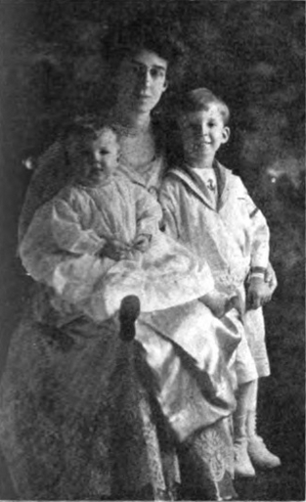
Kennedy, Lucy Belle (1880–1962)

Parents: Julian Kennedy (1852–1932) and Jane Eliza Brenneman (1852–1930).
Married: John Oliver Miller (1876–1963).
Children: Julian Miller (1910–2001); Eliza Miller (1914–2007); Barbara Miller (1918–1957).
Kinship: Grandaunt of the post–World War II Smith generation.
Early Life and Education
Lucy Belle Kennedy was born on October 11, 1880, in Braddock, Pennsylvania, into a family deeply involved in both industry and reform. Her father, Julian Kennedy, was an engineer and industrialist; her mother, Jane Eliza Brenneman, was active in the women’s rights and suffrage movements. The family moved to Pittsburgh around 1892, where Lucy attended the Winchester Thurston School and graduated from Vassar College in 1902.
On May 1, 1907, she married John Oliver Miller at the Kennedy family home on Forbes Street in Pittsburgh, with her sister Eliza as her attendant and three of her brothers serving as ushers. Lucy and John Miller made their home in Pittsburgh, where she became increasingly engaged in social reform and women’s rights advocacy.
Suffrage and Women’s Rights Advocacy
Lucy Kennedy Miller’s public work began soon after her marriage. By 1909 she was active in Pittsburgh’s emerging suffrage organizations, first as a member and later as an organizer of the Allegheny County Equal Rights Association, which later became the Equal Franchise Federation of Western Pennsylvania. She became its treasurer and, by 1912, president.
That same year, she helped organize a groundbreaking “Women’s Suffrage Edition” of the Pittsburgh Post, written, edited, and produced entirely by women. The edition promoted women’s civic participation, celebrated international progress toward suffrage, and achieved record circulation for the paper.
Her leadership brought her to statewide prominence. She became president of the Pennsylvania Equal Franchise Federation and later of the League of Women Citizens of Pennsylvania—the forerunner of the Pennsylvania League of Women Voters. In 1919, after the Pennsylvania legislature ratified the Nineteenth Amendment, Lucy became the first woman ever to address that body. In her address, she praised the state’s role in securing ratification and predicted that women’s votes would reshape national politics.
She was soon described by contemporaries as “the woman to whom, more than to any other, Pennsylvania owed the triumph of suffrage.” In recognition of her role, the League of Women Citizens established the Lucy Kennedy Miller Fund, an endowment for educational and civic programs supporting women’s participation in government.
Public Integrity and Reform Efforts
After the ratification of women’s suffrage, Lucy redirected her reform energy toward civic accountability. With her sister, Eliza Kennedy Smith, she exposed widespread corruption in Pittsburgh’s city government during the 1930s. Their investigations into Mayor Charles H. Kline’s misuse of city funds led to his indictment on forty-eight counts of malfeasance and his conviction in 1932. The sisters’ activism helped lay the groundwork for later reforms in city budgeting and public oversight.
Later Life and Relocation to Maryland
In 1928, Lucy and her husband purchased Emerson Point, a historic property in Talbot County, Maryland. They divided their time between Pittsburgh and the Eastern Shore until John’s retirement. Emerson Point later passed to their daughter Eliza Miller, an artist, who preserved it until her death in 2007.
Illness and Death
Lucy Kennedy Miller was diagnosed with carcinoma of the bowel in 1962. She was hospitalized at West Penn Hospital in Pittsburgh, where she died on June 30, 1962, at the age of eighty-one. Her remains were cremated at Homewood Cemetery, and a memorial service was held at St. Michael’s Church in Maryland.
Legacy
Lucy Kennedy Miller’s legacy endures as that of a pioneering suffragist, reformer, and civic leader. She combined the industrial-era discipline of her father’s generation with the moral and civic idealism of the Progressive Era. Her leadership of the Equal Franchise Federation and the League of Women Citizens helped secure the vote for Pennsylvania women and promoted a vision of ethical, efficient, and participatory government that remained central to the Kennedy family’s public philosophy.

Kennedy, Reid (1864–1953)
Burgess, Banker, and Strike Leader
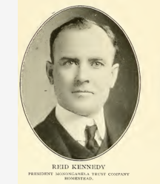

Parents: David Stewart Kennedy (1834–1898) and Nancy Wills Kelly (1837–1921).
Married: Martha E. West (1865–1946).
Children: None recorded.
Kinship: First cousin three times removed of the post–World War II Smith generation.
Early Life and Education:
The son of a United Presbyterian minister, Reid went to Illinois in 1878 and worked as a farmhand and later as a steelworker in Homestead to earn money for college. He entered Westminster College in 1885 and graduated in 1889. Both his parents were alumni of that college, and his grandfather had donated one of its early buildings.
Career and the Homestead Strike:
Reid moved to Homestead to work as a roller in the armor plate mills of the Carnegie Steel Company. During the Homestead Strike of 1892 he was one of thirty-three members of the Advisory Committee of the Amalgamated Association. All were indicted on charges of aggravated riot, conspiracy, and treason against the Commonwealth of Pennsylvania for allegedly forming “a government within a government.”
The prosecution collapsed because the Pennsylvania treason statute required actual armed insurrection, and juries and judges refused to equate strike organization with rebellion. Many viewed the charges as a ploy to crush the union. No convictions followed.
Public Service:
After the strike Reid organized a building-supply company and then turned to real-estate development in West Homestead Borough. A staunch Republican, he served as Burgess of Homestead (later Mayor) from 1897 to 1900, performing both administrative and judicial duties. In 1898, at the opening of the Carnegie Library in Homestead, he met Andrew Carnegie and Henry Clay Frick and gave the final address—reported, curiously, in The Dunfermline Journal and Advertiser for the West of Fife.
Judicial Anecdote:
Among his cases was the famous “Goat Affair”:
Burgess Reid Kennedy of Homestead had a goat up before him on a charge of disorderly conduct. On the docket he was listed as “William, alias Billy Goat,” accused by citizens of West Street of being a nuisance. After a chaotic arrest that left two boys dragged downhill, Kennedy resolved the case by ordering the owner to confine the goat and keep him out of town.
Law Enforcement and Civic Activity:
Reid organized raids against speakeasies, poker clubs, and “coat-and-pants” gambling houses; dismantled hobo encampments; tried to halt an illegal prizefight that ended fatally; and once rescued laborers overcome by gas in a street excavation. In 1905 he ran unsuccessfully for County Treasurer on a fusion ticket.
Financial and Civic Leadership:
In 1901 Reid became the first president of the Monongahela Trust Company of Homestead, serving until 1942. He was also treasurer of the Orient Coke Company, of which Julian Kennedy was president, with O. W. Kenney and S. A. Kennedy as associates. He represented Julian Kennedy in several business negotiations and served as chairman of the finance committee for Homestead Hospital, laying its cornerstone in 1922. He later chaired the 1926 capital campaign for Westminster College.
He was a member of the Duquesne Club, Longue Vue Club, Oakmont Country Club, and the Bankers Association of Pittsburgh.
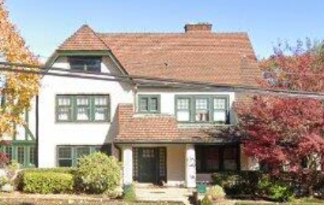
Residences and Personal Life:
In 1918 architect Paul W. Irwin designed a residence for him at 6553 Beacon Street, Squirrel Hill, Pittsburgh. The Kennedys wintered in Orlando, Florida, at the Amherst Apartments. Mrs. Kennedy was active socially, and Reid was an accomplished golfer whose holes-in-one were occasionally reported in the press. Their absences from Pennsylvania, widely noted in society columns, unfortunately invited burglary: the Homestead home was looted in 1918, and the Squirrel Hill residence suffered similar break-ins in 1942 and 1950.

Kennedy, Samuel A. (1867–1953)
Industrial Engineer and Civic Leader

Parents: Thomas Walker Kennedy (1824–1896) and Margaret Truesdale (1824–1907).
Married: Elizabeth P. Warner (1870–1950).
Children: Anne Kennedy (1896–1989); Henry Warner Kennedy (1898–1987); Walker Kennedy (1901–1989).
Kinship: Great-granduncle of the post–World War II Smith generation.
Early Life and Education
Samuel A. Kennedy was born in Poland, Ohio, the sixth of the seven sons of Thomas Walker Kennedy and Margaret Truesdale. He was educated as an engineer and graduated from Geneva College, a path followed by several members of the extended Kennedy–Truesdale families who favored practical, technical training.
Career
After completing his studies, Kennedy moved to Chicago, where he became general manager of the Iroquois Iron Company, a significant position during a period of rapid industrial expansion in the Midwest. In 1923 he accepted an appointment in Utah to oversee construction of the Columbia Steel Plant in Provo, a major development in the Intermountain West’s industrial infrastructure. His work there helped establish the steelmaking capacity that would later be crucial during World War II.
Public Service
During the Second World War, Kennedy served both on the local Selective Service Board and on the appeals board, positions requiring judgment, administrative skill, and a reputation for fairness. His service marked him as one of the responsible civic figures in wartime Utah.
Civic and Religious Life
Kennedy was a member of the United Presbyterian Church, the Alta Club, and the Salt Lake City Country Club. He served as a director of The First Security Bank, indicating his integration into the financial leadership of the region. In recognition of his work related to regional water planning and oversight, he was made an honorary member of the Metropolitan Water District of Salt Lake City.

Kennedy, Thomas Walker (1824–1906)
Engineer and Industrialist

Parents: James Bailey Kennedy (1794–1873) and Sarah Reid (1792–1873).
Married: Margaret Truesdale (1824–1907).
Children: Julian Kennedy (1852–1932); James Kennedy (1853–1928); Hugh Kennedy (1856–1929); Rachel Kennedy (1859–1935); Walter Truesdale Kennedy (1861–1924); John Harrison Kennedy (1864–1945); Samuel A. Kennedy (1867–1953); Thomas Walker Kennedy Jr. (1869–1962).
Kinship: Second great-grandfather of the post–World War II Smith generation.
Early Life and Family Background
Thomas Walker Kennedy was born into a New England family that had migrated westward during the early settlement of the Connecticut Western Reserve. His father, James Bailey Kennedy, originally from Connecticut, moved to northeastern Ohio to take up farming, part of the broad movement of Yankee settlers who carried New England culture, religion, and work habits into the developing frontier. Thomas grew up in this environment of agricultural self-reliance and expanding industrial opportunity.
Career and Industrial Development
Remaining in Ohio throughout his life, Thomas played a pioneering role in the industrial development of the Mahoning Valley. He built the first blast furnace in the region, a landmark accomplishment in an area that would later become one of the great centers of American iron and steel production. His work in ironmaking placed the Kennedy family at the forefront of the valley’s early metallurgical enterprises.
In addition to iron production, he established the Lowell Milling Company, expanding the family’s business interests into grain processing. This diversification reflected the economic energy of the mid-nineteenth-century Western Reserve, where transportation improvements and population growth encouraged new forms of manufacturing.
Influence on Descendants
Thomas Kennedy’s fascination with metallurgy and mechanical processes profoundly shaped the educational and professional paths of his children. Several of his sons became engineers, and this technical inclination continued into later generations, with descendants contributing to mining, steelmaking, industrial design, and large-scale engineering projects across the United States and abroad. The global reach of these later accomplishments can be traced directly to Thomas’s early commitment to industrial innovation in rural Ohio.
Community and Legacy
Although not a public figure in the formal sense, Kennedy’s influence was widely felt through the enterprises he built and the professional directions he inspired. His life reflects the transformation of the Mahoning Valley from agricultural frontier to industrial powerhouse, and his descendants played a major role in carrying that transformation forward into the twentieth century.

Kennedy, Thomas Walker Jr. (1869–1962)
Industrial Executive

Parents: Thomas Walker Kennedy (1824–1896) and Margaret Truesdale (1824–1907).
Married: Florida Clifton Beach (1872–1927).
Children: Georgia Kennedy (1901–1997); James Hugh Kennedy (1905–1993); and one child who died in infancy.
Kinship: Great-granduncle of the post–World War II Smith generation.
Early Life and Education
Thomas Walker Kennedy Jr. was the youngest of the seven sons born on the family farm along Kennedy Road in Poland Township, Ohio, a property long associated with the pioneering industrial ventures of his father. Like his brothers, he was educated first at the Poland Seminary School, an institution that produced a number of prominent figures in northeastern Ohio. He graduated from Geneva College, continuing the family’s pattern of technical and managerial preparation.
Career
Kennedy spent his professional life in the iron and fuel industries, following the metallurgical path laid down by his father and older brothers. He served as superintendent of the Isabella Furnace, a significant position requiring technical expertise and managerial authority. He later became manager of the Adrian Furnace Company in DuBois, Pennsylvania, an important center of iron production during the early twentieth century.
His career subsequently moved into larger corporate responsibilities. He was president of the Mystic Iron Company of Boston and later president of the New England Gas and Fuel Company, positions that placed him within the upper ranks of the region’s industrial leadership. His professional trajectory demonstrates the continued expansion of the Kennedy family from local ironmasters in Ohio to executives in national and regional fuel and manufacturing companies.
Later Life
After retiring, Kennedy settled in Wiscasset, Maine, where he enjoyed a quieter life far from the industrial centers in which he had spent his career. He was known to be an avid golfer, a pastime he maintained into his later years.

Kennedy, Walter Truesdale (1861–1924)
Engineer and Imperial Advisor in China

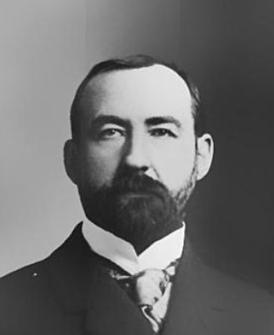
Parents: Thomas Walker Kennedy (1824–1896) and Margaret Truesdale (1824–1907).
Married: Mary Anne McCutcheon (1854–1922).
Children: Mary Francis Kennedy (1887– ); Rachel Kennedy (1888–1890); Walter Truesdale Kennedy (1892–1960); Martha Ellen Lou Kennedy (1894–1943).
Kinship: Great-granduncle of the post–World War II Smith generation.
Early Life and Training
Walter Truesdale Kennedy was born on the family farm in Poland, Ohio, the fourth of the seven Kennedy sons. Like his brothers, he attended local schools and was trained from adolescence in the blast furnaces of the Mahoning Valley. Beginning as an apprentice workman, he rose quickly through skill and determination to become superintendent of Carnegie’s Lucy Furnace, one of the major metallurgical operations in Pittsburgh. He later held senior positions with several steel companies in Steubenville before establishing himself as an independent consulting engineer.
Mission to China
In 1896 Senator Calvin S. Brice and J. Pierpont Morgan engaged Kennedy to travel to China in anticipation of securing a railway concession. Although Brice died and the scheme collapsed, Kennedy remained in China, accepting employment with the Imperial Government. His letters and later recollections reveal the profound cultural adjustments required of a Western engineer in late Qing China. He later remarked that during his first two weeks he could scarcely sleep because of the “shocking scenes” he witnessed.
At first he enjoyed the full confidence of Imperial officials. He managed the iron and steel works at Han Yang and the arsenal at Wu Chan Fu, and was placed in charge of Mining and Metallurgical Work for the Empire. His responsibilities expanded further when he was appointed First Secretary of the Chinese Imperial Railway.
Cultural Challenges and Danger
Kennedy’s accounts vividly describe the obstacles faced by foreign engineers operating within traditional Chinese administrative structures. He noted that many officials believed that altering the natural landscape violated divine order, concluding that “anything which God has made shall not be disturbed by the hand of man.” Engineering projects could be halted if they were thought to offend the feng shui, the spiritual force governing natural harmony. Even a proposed chimney was rejected because it was believed to interfere with the feng shui.
Life and work were perilous. Kennedy discovered that he had no authority over hiring and firing; those decisions were made by Mandarin officials who took payments from workers in lieu of salaries. Attempts by sympathetic workers to assist him were met with brutal reprisals. He recalled that several of his employees were beheaded merely for working with an American, and he himself fell into a state of extreme stress, losing more than sixty pounds.
His status at court alternated between privilege and captivity. On inspection tours he traveled with strikingly elaborate retinues: an Imperial guard of twenty-five soldiers, three mandarins, 139 chair carriers, and “an innumerable caravan of coolies, cooks, etc.” He had a government launch at his disposal and was assigned 208 servants, yet possessed little real autonomy. When appointed Secretary of the Imperial Railway, he was effectively imprisoned; he was forbidden to return to the mill even to retrieve his clothing and cut off from communication with the United States. His family feared he had been executed. Eventually he succeeded in escaping his situation and returned home deeply grateful for the protections of the United States government.
Later Career and Writings
After returning from China, Kennedy resumed his work as a consulting engineer for steel firms in the United States and Canada. He explored the feasibility of establishing steel mills in San Diego and Utah and authored “A Century of Blast Furnace Practice” for The Industrial World (1901). His experience in China led him, in 1912, to warn American manufacturers of the potential rise of Chinese industrial capacity. Citing the country’s immense resources and extremely low labor costs, he predicted that China would eventually become a formidable competitor and argued that high tariffs were the only protection for American industry.
Personal Life
Kennedy lived at 15 West McIntyre Avenue in Pittsburgh and was a member of the First United Presbyterian Church, Northside. His life, marked by intense technical achievement and extraordinary adventure abroad, reflects the global reach of American engineering at the turn of the twentieth century and the distinctive ambitions of the Kennedy family.

Kilham, Lawrence Breese (1941– )
Inventor, Industrialist, and Writer

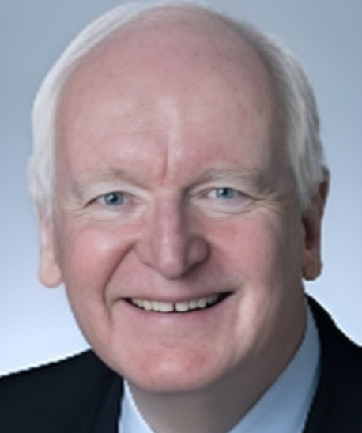

Parents: Peter Houston Kilham (1905–1992) and Frances Potter Breese (1916–1997).
Married: Betsy S. Spaulding (1927- ).
Children: None recorded.
Kinship: Eighth cousin once removed of the post–World War II Smith generation.

Education and Early Technical Career
Lawrence (“Larry”) Breese Kilham earned a B.S. in Engineering Physics from the University of Colorado and a master’s degree from the Sloan School of Management at MIT. Entering the high-technology sector in 1965, he worked in engineering, sales, and management roles for several advanced manufacturing and instrumentation firms. He developed three patented innovations in chemical-process instrumentation, and in 1986 received the IR 100 award for one of the year’s most significant technical products. His articles appeared widely in trade journals and were presented at professional conferences. Much of his career was international, taking him to Asia, Europe, the Middle East, and Latin America; he became fluent in Spanish and later wrote a bilingual memoir of his work in Nicaragua, Shades of Truth / Los matices de la verdad.
Eco Sensors
In 1991 Kilham founded Eco Sensors, a small company specializing in ozone-sensing technology. Initially based in New Jersey, the firm was later relocated to Santa Fe, New Mexico, where Kilham had longstanding family ties through his maternal grandfather, the inventor and aviator James L. Breese. In early 2008 he sold the company to KWJ Engineering of the San Francisco Bay Area. Although KWJ considered moving operations to California, it determined that Santa Fe offered lower costs and a skilled, cohesive team; the business remained on Pacheco Street with a staff of seven.
Kilham continued to serve as a board member and consultant after the sale. At the time, he described himself as “needing more time for skiing” and welcomed the security the transaction provided. He noted that Eco Sensors’ relationship with KWJ would facilitate improvements through micromachining and nanotechnology, strengthening the shared mission “to keep the world as safe as we can from dangerous gases.”
Family Background in Santa Fe Technology
Kilham’s grandfather, James L. Breese, was an early high-tech entrepreneur in Santa Fe. Breese designed and built oil burners known as Breese Burners and maintained both a laboratory on Canyon Road and a plant on Cerrillos Road. A mechanical prodigy, he served as flight engineer on the NC-4 biplane that made the first trans-Atlantic flight in 1919. During World War II and the Korean War he worked closely with the U.S. Army. His Canyon Road property later served as the stand-in for Santa Fe High School in the film Red Sky at Morning and as an interim campus for Santa Fe Preparatory School. Breese was widely respected in the city; family tradition holds that Oliver LaFarge wrote his obituary for The New Mexican.
Kilham often recalled his grandfather’s judgment that Santa Fe was “a charming place to live but not a great place to have a high-tech business,” an observation he believed had not entirely changed. Although the state assisted him with foreign-trade programs, he noted the persistent difficulty of recruiting skilled labor locally.
Transition to Writing
After retiring from industry in 2007, Kilham became a full-time writer, drawing on skills cultivated as a college newspaper editor.
Category | Select Works | Focus
Entrepreneurship | Great Idea to a Great Company; Megaminds | Explored the processes of invention and entrepreneurship, drawing on family experience.
Fiction (Juno Trilogy) | Love Byte; A Viral Affair; Saving Juno | Novels centered on artificial intelligence and virtual-reality technology in the drug wars.
Nonfiction | The Winter of the Genomes; The Digital Rabbit Hole | Examined the implications of robotics and digital media (2014–2016).
Memoir | The Perfectionist; Destiny Strikes Twice | Portraits of his inventive father (Peter Kilham) and aviator grandfather (James L. Breese).
Poetry | The Magic of Nature; Dirt Road Poems | Reflecting his long engagement with nature, technology, and memory.

Kristin Colgan Kuhns (1948-2021)
Writer and Filmographer

Parents: James L. Kuhns (1918–2001) and Faith Hallock Colgan (1920–2000).
Married: (1) William Norris Hubbard (1941- ); (2) Richard Warren Gerrity (1942–); (3) DeWitt Loomis Alexandre II (1949– ).
Children: None recorded.
Kinship: Wife of the second cousin of the post–World War II Smith generation.
Early Life and Education:
Kristin was born and raised in Dayton, Ohio, where her family had deep roots. She attended and graduated from Sweet Briar College in Virginia. Her upbringing in Dayton later inspired her creative work; her graphic novel series, Nuncio and the Gypsy Girl, features Neci Stans, a Dayton gypsy princess whose love for Ezra Crawford, a local aviator and composer, brings her into peril.
Career and Writing:
She helped lead New York City’s first Earth Day celebration on April 22, 1970, serving as speaker coordinator for the event. Kristin wrote feature stories for The Christian Science Monitor, Ingenue Magazine, Town & Country, and the New York Daily News, and contributed a weekly column, “The Young Slant,” for the Dayton Journal Herald. Her first professional writing experience came with the Kettering-Oakwood Times, where she chronicled her experiences in France with The Experiment in International Living.
She later worked as a publicist for Ammirati Puris Lintas, the Puerto Rico Economic Development Administration, Rums of Puerto Rico, and Sweet Briar College. She was also editor of the corporate magazines for Champion International, U.S. Plywood, and C.I.T. Financial Corporation. In the early 1970s she appeared as a reporter on an episode of WNET’s The 51st State.
Later Career and Film Work:
Kristin served as president of The Kuhns Investment Co. LLC, a small, privately held family investment company in Dayton. She also worked as a producer and writer for several film projects and was a featured writer on The Black List.
Filmography:
• 2012 Delivering the Goods – Co-Executive Producer
• 2013 Dear Margaret – Associate Producer
• 2016 Collected Kingdom – Executive Producer
• 2017 Dead Reckoning / Altar Rock – Producer, Writer
• 2017 Grey Lady – Associate Producer
Bibliography:
• Nuncio and the Gypsy Girl in the Gilded Age
• Gem City Gypsy (2013)
• Find a Great Guy: Now and Forever (2008)
• The Perfect Gentleman: The Secrets Rich Girls Use to Choose the Classiest Guys (2007)
(It may be noted that DeWitt Loomis Alexandre II could consider himself the model for the latter.)

